Introduction to AutoCAD

Lesson 1 AutoCAD Basics

This course is designed to introduce you to the CAD software package and get you started using some basic AutoCAD tools.

The main aims of the course are to

* Introduce you to the AutoCAD platform
* Guide You through the use of the most common tools
* Help you to set up and layout drawings within the main window
* Show you how to scale and modify drawings
* Demonstrate how to plot completed drawings.

Having attended the “AutoCAD Basics” class, Lesson 1 you will be able to….

1. Set up the drawing limits.
2. Identify and set preferences for drawing aids.
3. Zoom and pan the drawing area.

1.Set up the drawing limits

It is important to set up the drawing space at the beginning of a project as everything in AutoCAD should be drawn once in model space, full-size and then scaled afterwards to fit whatever application needed in paper space.

1.1. Drawing limits: The first page is to be set up size A4 landscape. (297 x 210) In the command bar, type “limits” and click , then set co-ordinate limits for bottom left corner and top right corner. (bottom left: type “0,0” and , and top right: type “297, 210 and ,). Then type “Z “and , and “E” and . This will zoom to the LIMIT extents that we have just set out.

## 2.Identify and set preferences for drawing aids

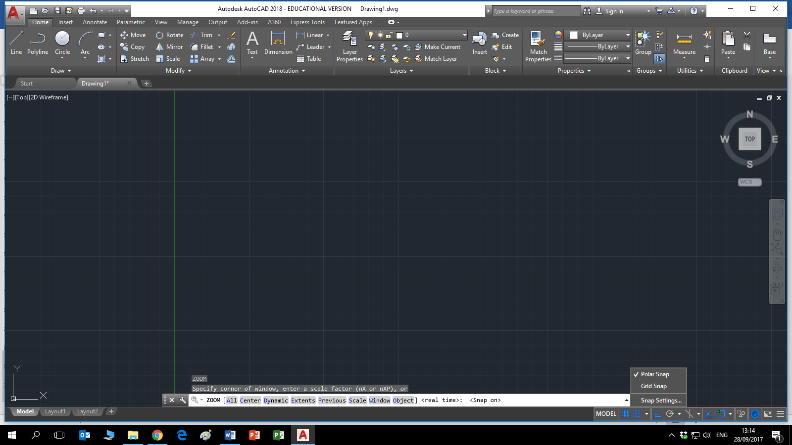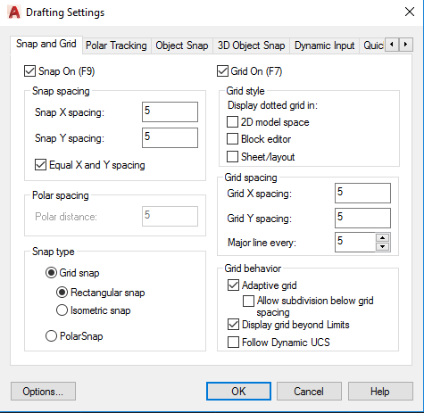 2.1. Snap and Grid: With Snap mode turned on AutoCAD only allows you to pick points, which lie on a regular grid. The Snap grid is completely independent of the display grid. However, the Grid spacing and Snap spacing are usually set to the same value to avoid confusion. Turn on both snap & grid then right click the drop-down arrow and select “SNAP SETTINGS” to change the preference settings for both snap and grid. Set Grid Snap X and Y to 5 and 5, and display Grid to 5 and 5.

2.2. Object snap: The Object Snaps (Osnaps) are drawing aids, which are used in conjunction with other commands to help you draw accurately. Osnaps allow you to snap onto a specific object location when you are picking a point. Osnaps in AutoCAD are so important that you cannot draw accurately without them.

2.3. Ortho: Ortho is short for orthogonal, which means either vertical or horizontal. Ortho is not really a command; it is a drawing mode which can either be turned on or off.

## 3.Zoom and pan the drawing area

3.1. Zoom: The window can be zoomed by simply scrolling the wheel on the mouse and it can be panned by clicking the scroll button and dragging the mouse. Alternatively these commands may be accessed through the command bar type “z”  then “a”  to zoom all.

## Activity 1

* Open AutoCAD.
* Set the drawing limits to A4 landscape.
* Set Grid Snap to 10mm, 10mm.
* Set display Grid to 10mm, 10mm.
* Zoom drawing limits Z  A .
* Click on the draw line tool then type in coordinates 0,0 and  then draw a vertical line upwards 210mm  then a horizontal line to the right 297mm, another vertical line downwards 210mm and a horizontal line to the left 297mm   Save the file as Activity 1, in a folder called AutoCAD week 1, on your Desktop.

## Activity 2

* Take a copy of the file “Solar System” from the AutoCAD webpage “[Workbook Section](https://www.learning101.ie/autocad.html)”., paste it into your AutoCAD week 1 folder and Open it up.
* Using pan and zoom controls fill in the values for all the planets starting closest to the sun.
* When you are finished both of these activities email me [robert.hickey@tudublin.ie](mailto:robert.hickey@tudublin.ie) a copy of the AutoCAD file from activity 1 and a screenshot or snip of the table opposite filled in.

|  |  |
| --- | --- |
| Planet | Diameter/Km |
| Sun | 1,392,000Km |
|  |  |
|  |  |
|  |  |
|  |  |
|  |  |
|  |  |
|  |  |
|  |  |
|  |  |