Introduction to AutoCAD

Lesson 4

Modify Toolbar

Introduction:

Before you start to use the AutoCAD Modify commands, you need to know something about selecting objects. All of the Modify commands require that you make one or more object selections. The first part of this session is designed to demonstrate the use of some of the selection options whereas the second part of this session introduces the modify toolbar.

Having attended Session 4 Modify Toolbar, you will be able to:

1. Select objects using 2 different methods.
2. Erase, Copy, Mirror and Offset objects.
3. Use rectangular and Polar Array.
4. Move, Rotate, Scale and Stretch objects.
5. Trim, Extend, Chamfer Fillet and Explode.

1. Select objects using 2 different methods

Perhaps the most obvious way to select an object in AutoCAD is simply to pick it. Generally, all you have to do is place your cursor over an object, click the left mouse button and the object will be selected.

* 1. 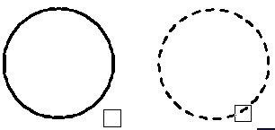Pickbox: To select an object, place the pickbox over a part of the object and left-click the mouse. When the object has been picked it is highlighted in a dashed line to show that it is part of the current selection. At this point you can continue adding more objects to the current selection by picking them or you can right click, press or the Space Bar to complete the selection.

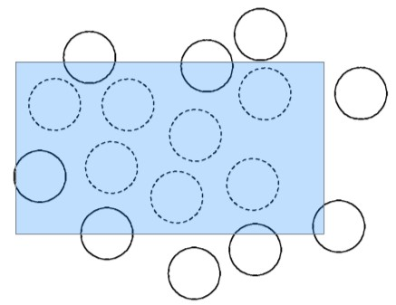

* 1. Window Selection: Window allows you to define a rectangle using two points. First left click once in the **top left corner** then move the mouse down diagonally and left click once again in the **bottom right corner**. When the window is defined in a left to right motion, all objects which lie entirely within the window will be selected. (see left)

* 1. 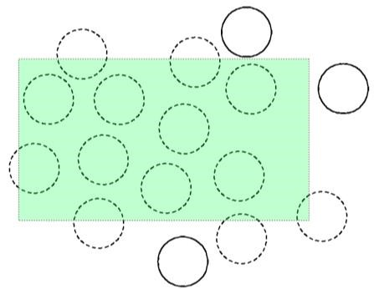Crossing Window Selection: The Crossing Window option is a variation of the Window command. The command sequence is exactly the same but the rectangle window is defined in a **right to left** motion and objects which lie entirely within the window and those which cross the window border will be selected. (see right)

Hint: When picking objects in a complex drawing, use the ZOOM commands to make object selection clearer and easier. It is possible to zoom during the selection process.

1. 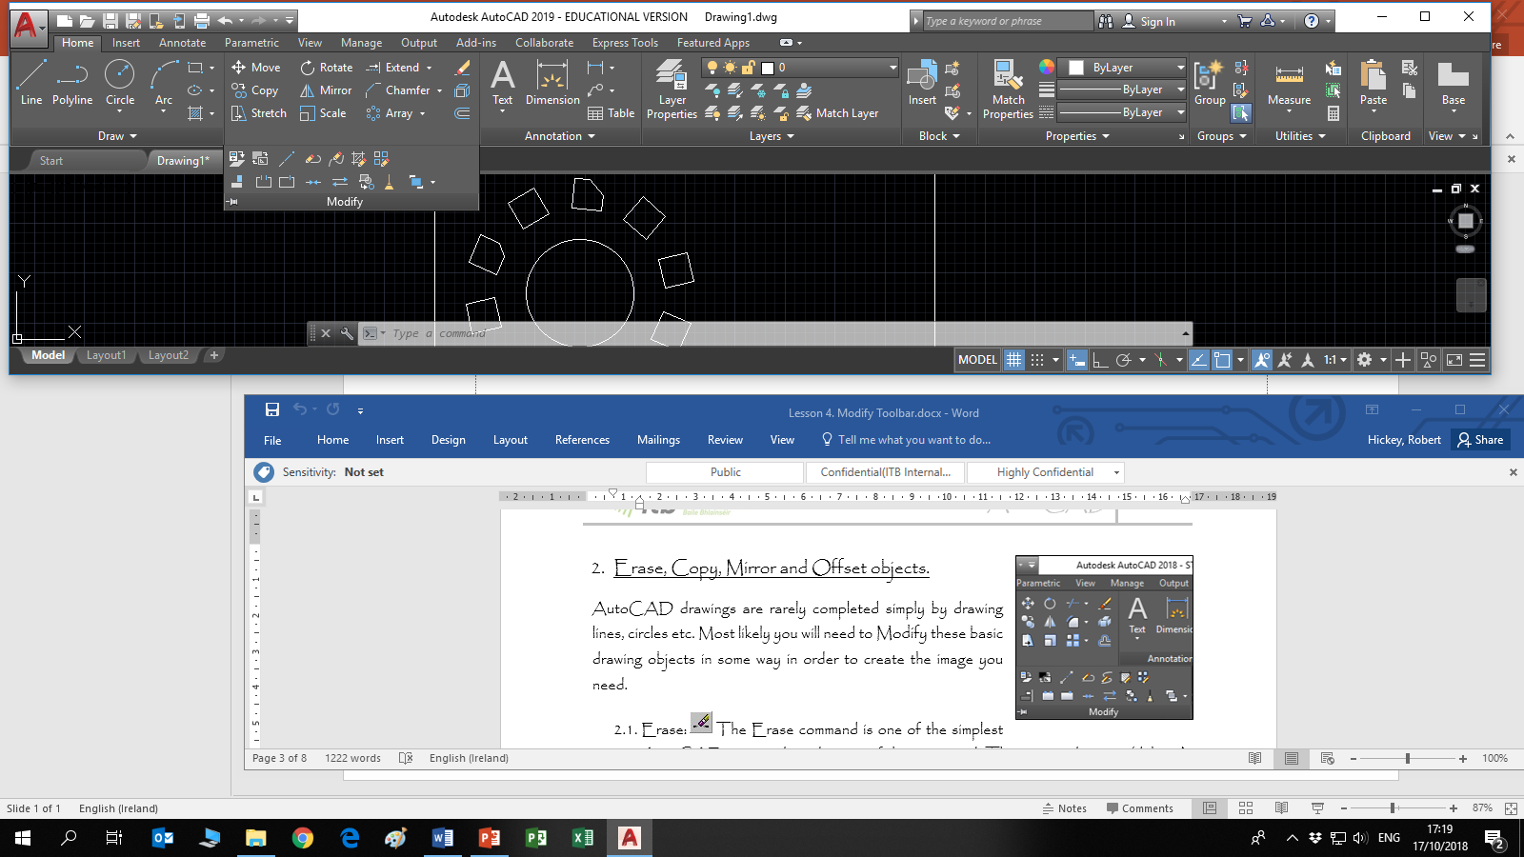Erase, Copy, Mirror and Offset objects.

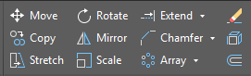AutoCAD drawings are rarely completed simply by drawing lines, circles etc. Most likely you will need to Modify these basic drawing objects in some way in order to create the image you need.

* 1. Screen ClippingErase: The Erase command is one of the simplest AutoCAD commands and is one of the most used. The command erases (deletes) any selected object(s) from the drawing. Remember you can always get deleted objects back by pressing

UNDO from the Quick Access toolbar



* 1. Copy: The Copy command can be used to create one or more duplicates of any drawing object or objects which you have previously created.



* 1. Mirror: The Mirror command allows you to mirror selected objects in your drawing by picking them and then defining the position of an imaginary mirror line using two points. In order to create perfectly horizontal or vertical mirror lines use Ortho.



* 1. 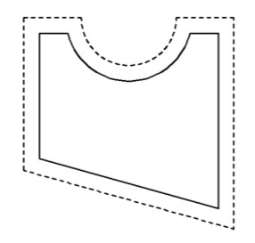Offset: The Offset command creates a new object parallel to or concentric with a selected object. The new object is drawn at a user defined distance (the offset) from the original and in a direction chosen by the user with a pick point. Left click the Offset tool, followed by  then type in the amount/distance you want to offset the object by and , click the object to offset and move the cursor in the direction you want the offset to be and left click, then .

1. Use rectangular and Polar Array.

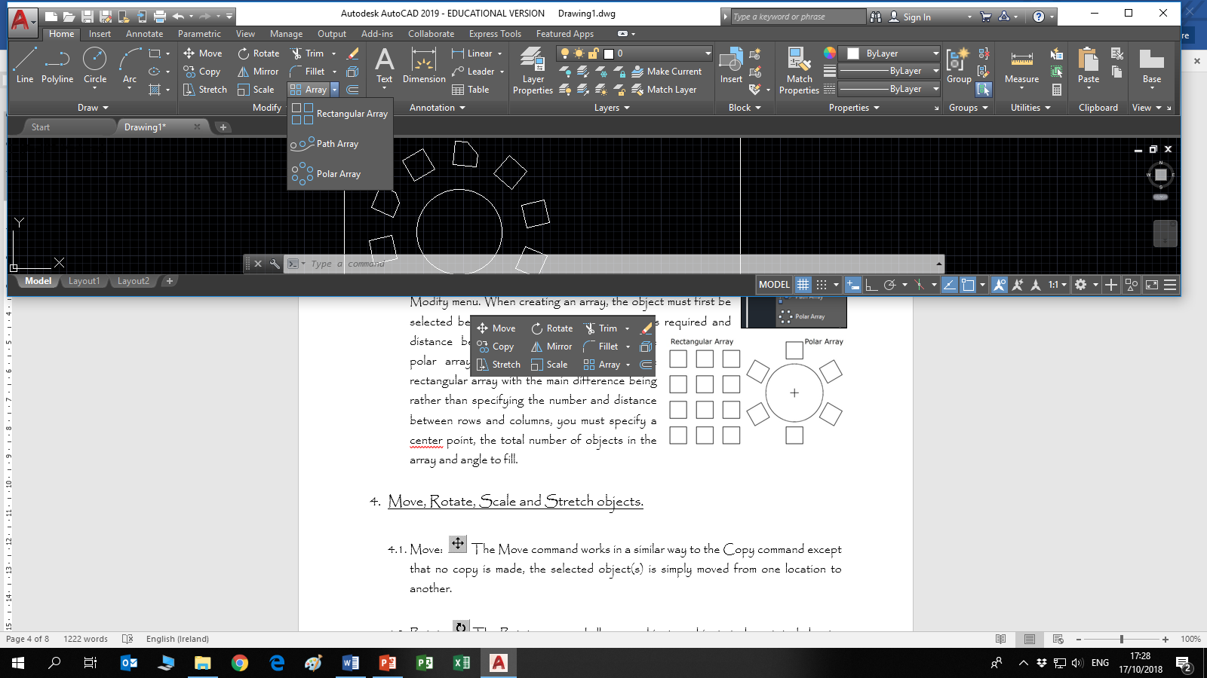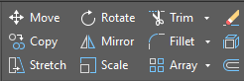

* 1. 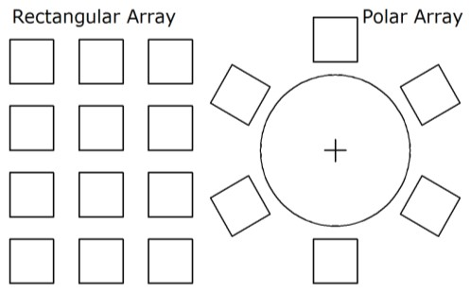Array: You can create a rectangular array directly from the Modify toolbar but polar array is accessed through the Modify menu. When creating an array, the object must first be selected before specifying the number of items required and distance between arrayed components. The polar array works in a similar way to the rectangular array with the main difference being rather than specifying the number and distance between rows and columns, you must specify a center point, the total number of objects in the array and angle to fill.

1. Move, Rotate, Scale and Stretch objects.



* 1. Move: The Move command works in a similar way to the Copy command except that no copy is made, the selected object(s) is simply moved from one location to another.



* 1. Rotate: The Rotate command allows an object or objects to be rotated about a point selected by the user. AutoCAD prompts for a second rotation point or an angle which can be typed at the keyboard. Remember, by default, AutoCAD angles start at 3 o'clock and increase in an anti-clockwise direction.



* 1. Scale: The Scale command can be used to change the size of an object or group of objects. When the items are selected, a base point must be selected before a scale factor can be inserted in the command bar.



* 1. Stretch: The Stretch command can be used to move one or more vertices of an object whilst leaving the rest of the object unchanged

1. Trim, Extend, Chamfer Fillet and Explode objects.

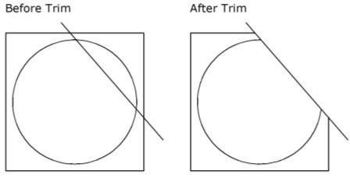

* 1. Trim: The Trim command can be used to trim a part of an object. In order to trim an object, you must draw a second object which forms the "cutting edge". The [Trim command](https://www.youtube.com/watch?v=Ogl_2PwMTv4), has been updated in AutoCAD 2021. It used to require two separate object selections. The **cutting edges** were selected first (one or more) and then the objects to be trimmed were selected. This option is still available in the command bar when Trim is selected.

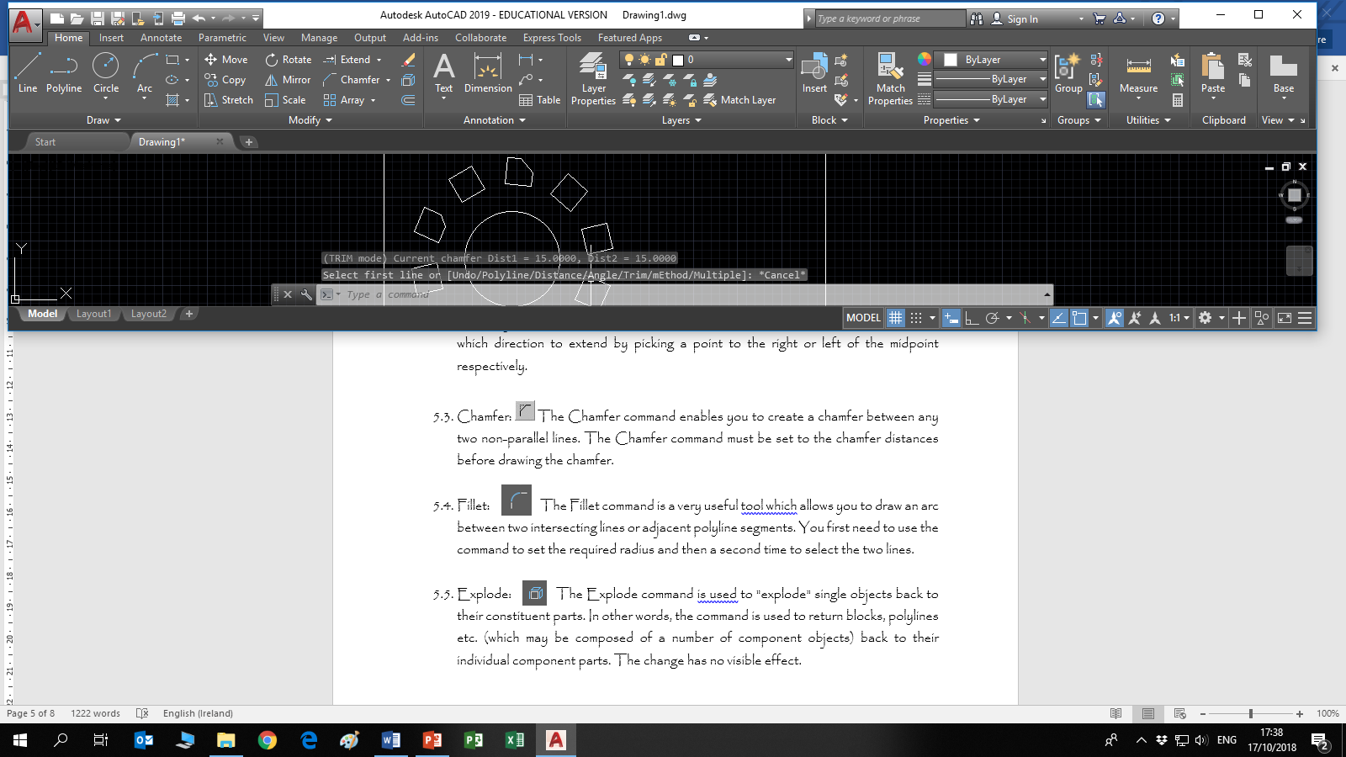

* 1. Extend: This command extends a line, to meet another drawing object. This command works in a similar way to the Trim command, described above. It has also been updated in AutoCAD 2021. It used to require that two selections be made, one for the **boundary edge(s)** and one for the object(s) to extend. This is still available in the command bar once extend is selected. You can tell AutoCAD in which direction to extend your line or object by picking a point to the right or left of the midpoint.



* 1. Chamfer: The Chamfer command enables you to create a chamfer between any two non-parallel lines. The Chamfer command must be set to the chamfer distances before drawing the chamfer.



* 1. Fillet: The Fillet command is a very useful tool which allows you to draw an arc between two intersecting lines or adjacent polyline segments. You first need to use the command to set the required radius and then a second time to select the two lines.



* 1. Explode: The Explode command is used to "explode" single objects back to their constituent parts. In other words, the command is used to return blocks, polylines etc. (which may be composed of a number of component objects) back to their individual component parts. The change has no visible effect.

Activity: 1

Open the file “Modify Toolbar 1” and complete all exercises associated with the tools on the modify toolbar.

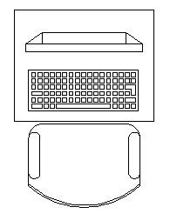Activity: 2

Open a new drawing in AutoCAD and draw each of the individual components required for the chair and desk keyboard & monitor.

Save your completed drawing as “Workstation”

Table: Chair:

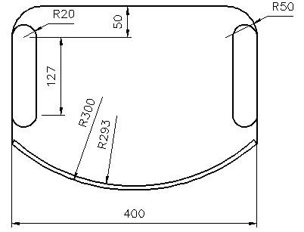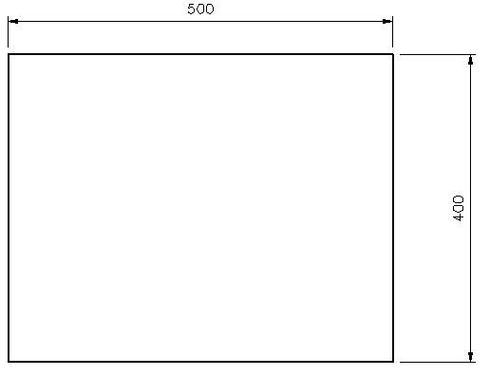

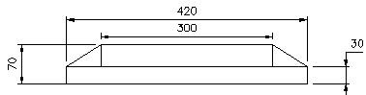Monitor:

Space between Keys is 7.5mm

Keyboard:

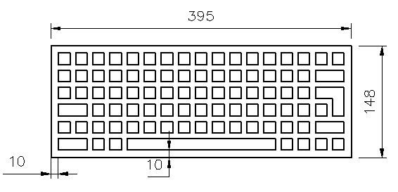

15x15

# Activity: 3

Open a new drawing in AutoCAD set up drawing space and draw the piece shown below.

55,65



# Activity: 4

Open a new drawing in AutoCAD set up

drawing space and draw the piece shown below.

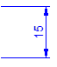

200,75

Ø20

Ø12

200,75

# Activity: 5

Open a new drawing in AutoCAD set up

drawing space and draw the piece shown below. When all drawings are complete email them to [Robert.hickey@tudublin.ie](mailto:Robert.hickey@tudublin.ie)

