Introduction to AutoCAD

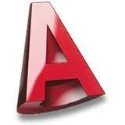Lesson 6

Dimensions

Having attended Session 7 Dimensions, you will be able to:

1. Apply dimensions to an existing drawing.
2. Set up new dimension styles.

This lesson describes the options and commands available for dimensioning drawings and how to use them. The correct use of AutoCADs dimension tools is key to producing clear and concise measured drawings.

## 1.Apply dimensions to an existing drawing

AutoCAD provides a whole range of dimensioning tools which can be used to quickly dimension any drawing without the need for measurement. Dimensioning in AutoCAD is automatic; lines, arrows and text are all taken care of by the dimension commands.

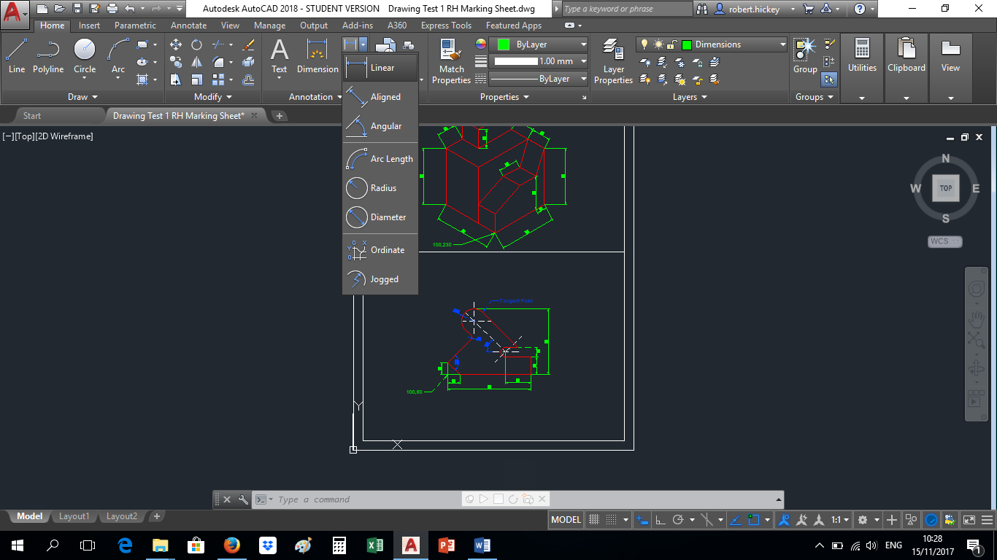AutoCAD divides dimensions into four main categories: Linear, Radial, Ordinate and Angular. When working with dimensions it is very important that line origins are picked accurately so that the resulting measurement and text are correct. Always use an Osnap (F3) to pick dimension line origins.

Dimension commands are available on the Home Tab,

in the Annotations Group, Dimension pull-down menu

and on the Annotation Tab, in the Dimension Group.

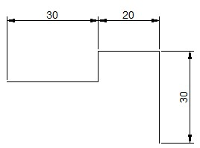1.1Linear Dimension

This command generates horizontal and vertical dimensions. Start the command, specify the two points between which you want the dimension to be drawn and pick a point to fix the position of the dimension line.

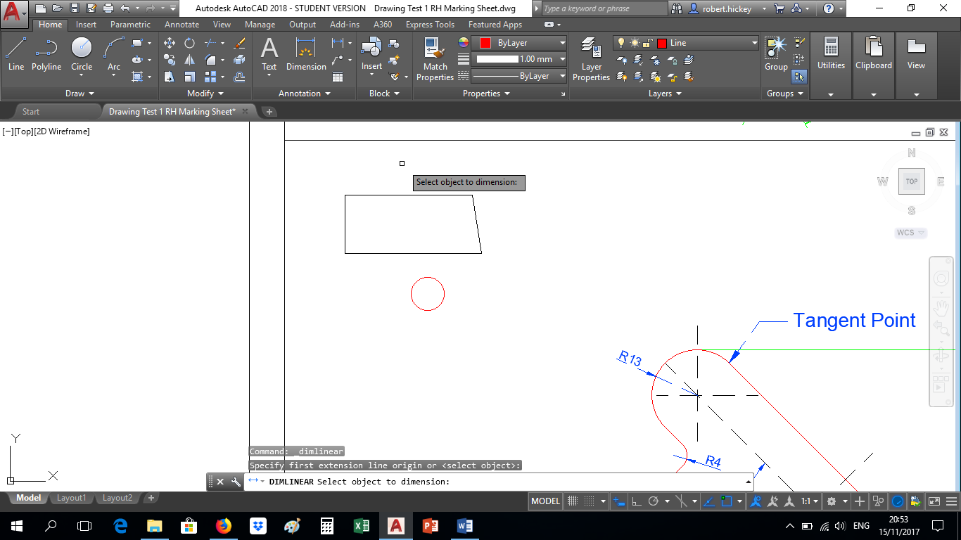TIP: AutoCAD allows you to dimension an object simply by picking it. Having selected “linear dimension” hit the Enter key to enable object selection. Then simply click on

the line you want to dimension.

1.2Aligned Dimension

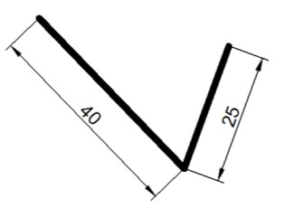You can use this command to generate aligned dimensions. These are dimensions along inclined lines which cannot be dimensioned with the linear dimension command because that command will only give a measured dimension in either a horizontal or vertical direction.

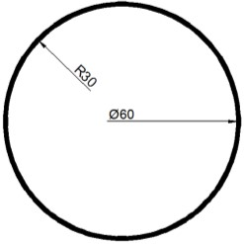1.3Radius & Diameter

There are two main radial dimension commands, Radius and Diameter. Both commands result in a similar looking dimension, so AutoCAD automatically inserts an "R" to indicate a radius and the diameter symbol to indicate a diameter dimension. The Diameter and Radius commands are supplemented with Centre Mark which can be used to add a centre mark to any circle or arc.

1.4Angular

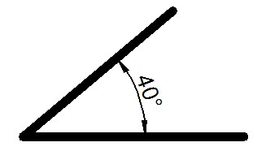The Angular command is amazingly flexible and can be used to indicate an angle in almost any situation. Just like the other dimension commands, all parts of the process are rubber banded so you can see the results of your actions before you make the final pick.

1.5Quick Dimension

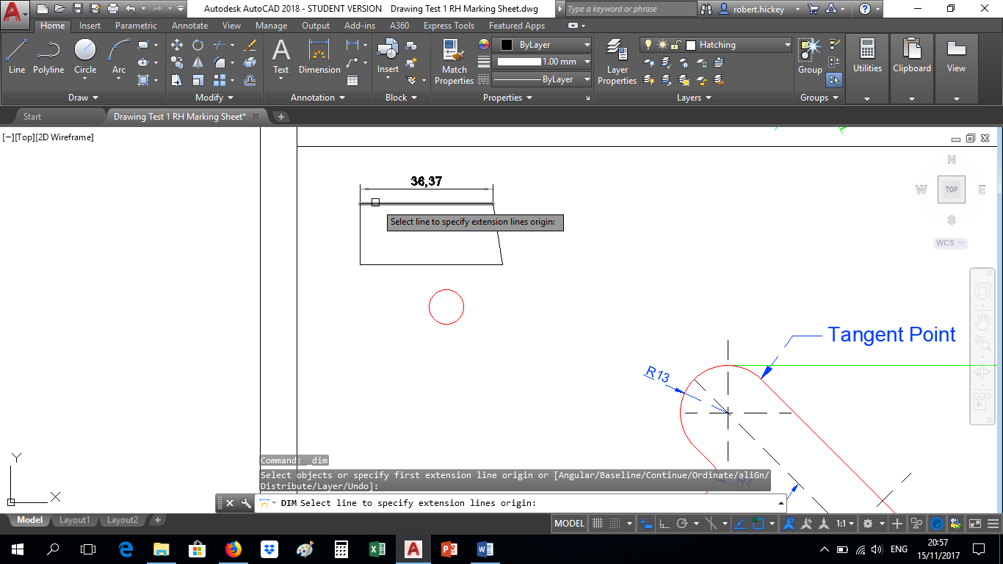The quick dimension command allows you to dimension a number of components in a single step. This is possibly the quickest way to dimension an object in AutoCAD. Click the quick dimension command in the Annotation Group and then hover your mouse over the line or object you want to dimension until pick box appears. Then simply left click and move the dimension to the desired position and click.

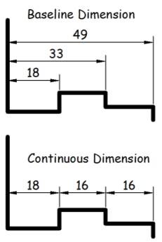1.6Baseline & Continuous Dimension

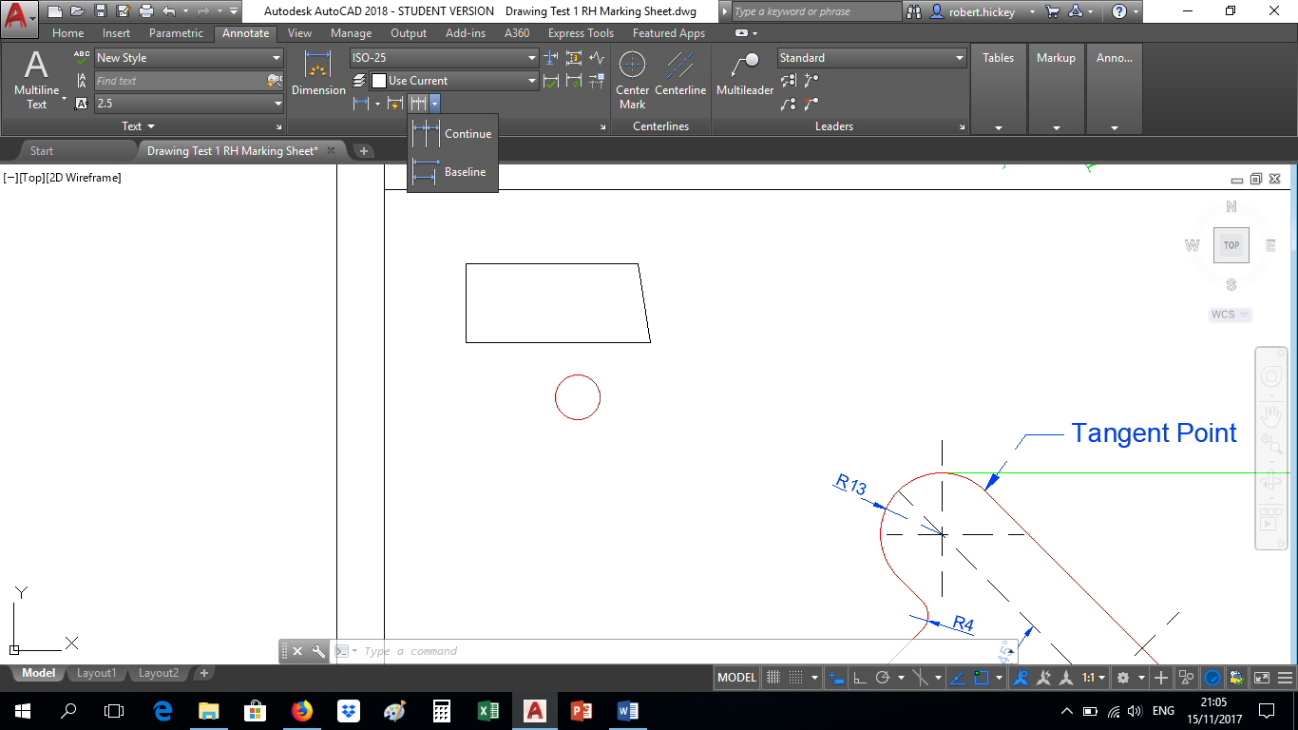These commands allow further functionality when applying dimensions. Baseline applies the dimension with reference to the original point whereas continuous will insert the dimension on a continuous basis with a single click. You can use the Continue command to add a string of dimensions. In the illustration, the "16mm" dimension has been continued from the "18mm" dimension.

1. Set up new Dimension Styles.

AutoCAD provides lots of control over the way dimensions look. Using a system similar to text styles, dimension styles allow you to design dimensions so that they look just the way you want them to. You can create a style of your own or modify existing styles.

2.1Dimension Styles

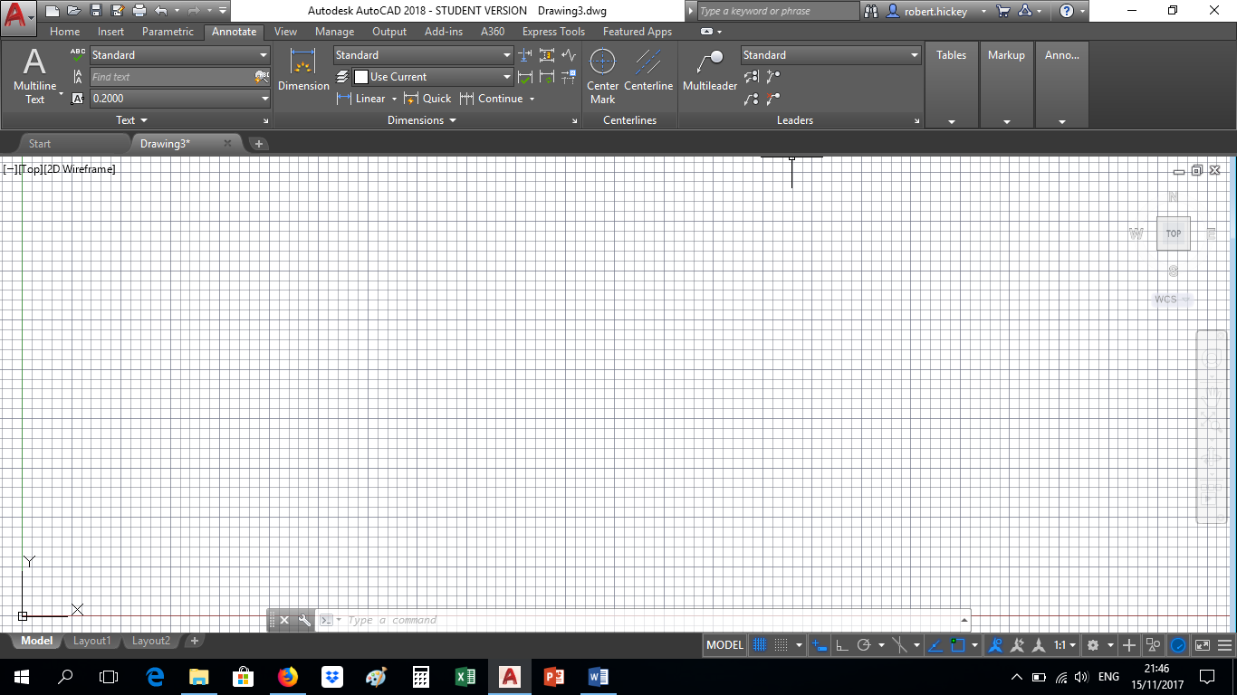 Dimension styles are the main method used to control the way dimensions look. Using styles, you can change the text font, the arrow head style, the relative position of the text, the scale of dimensions and many other parameters.

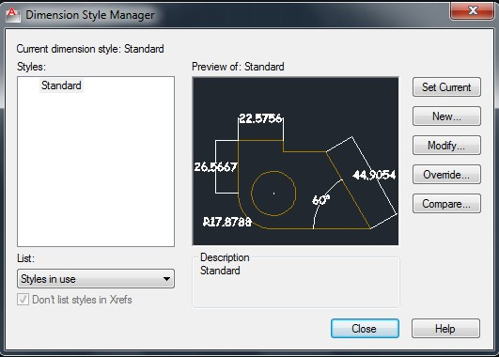It is best to create a new style before you start creating dimensions so that you can leave the unmodified STANDARD style as a default option. On the Annotation Tab in the Dimensions Group Click the arrow to launch the Style Manager dialogue box.

Having created a new style from STANDARD you can then apply any modifications you generally require to the new parent style and then more specific modifications to the child styles in order to create a style family.

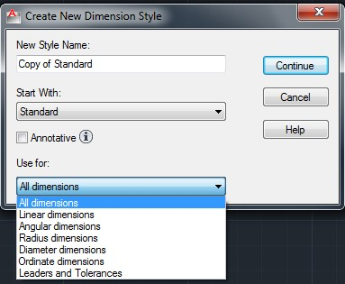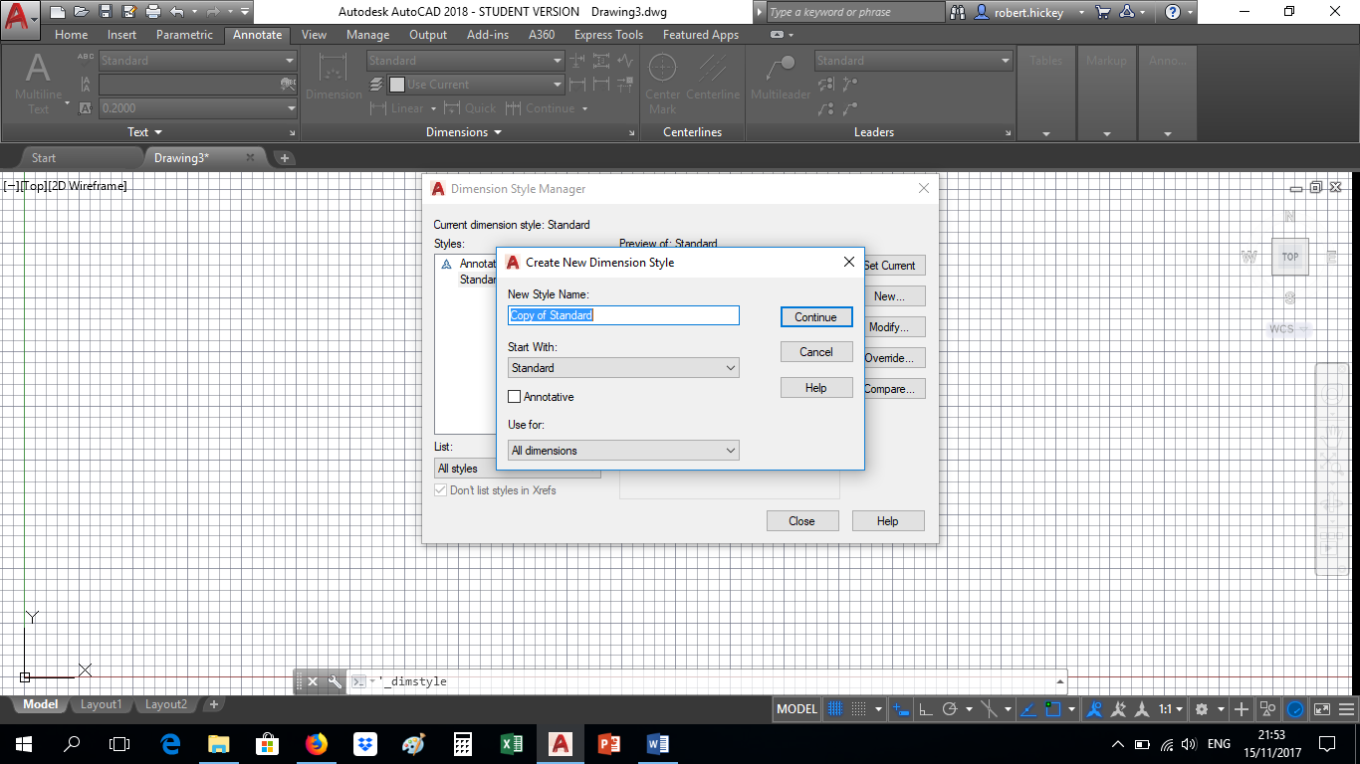As you can see from the dialogue box, a style is applied to a family of dimensions. By default, any style changes are made to the parent. Each style parent has six child styles. The child styles, Linear, Radial, Angular, Diameter, Ordinate and Leader can be used to modify the parent style when that particular type of dimension is used. For example, you may like to use a tick rather than an arrowhead for your dimensions, but this is not appropriate for a leader, so the Leader child style can be changed so that leaders will always be drawn with an arrowhead whilst all other dimensions of the same style family are drawn using ticks.

2.2Creating a new style

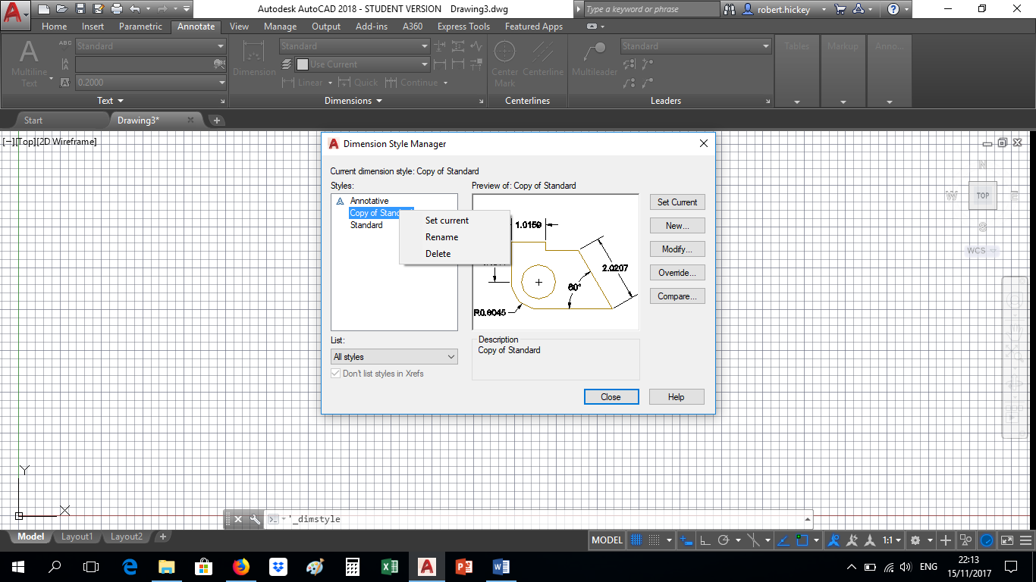 To create a new dimension style, click NEW and Name the new style you wish to create. Select the style from which you want to create the new style. The new style is automatically set as the current style. You may rename the new style if you wish, simply by right-clicking the style and Rename.

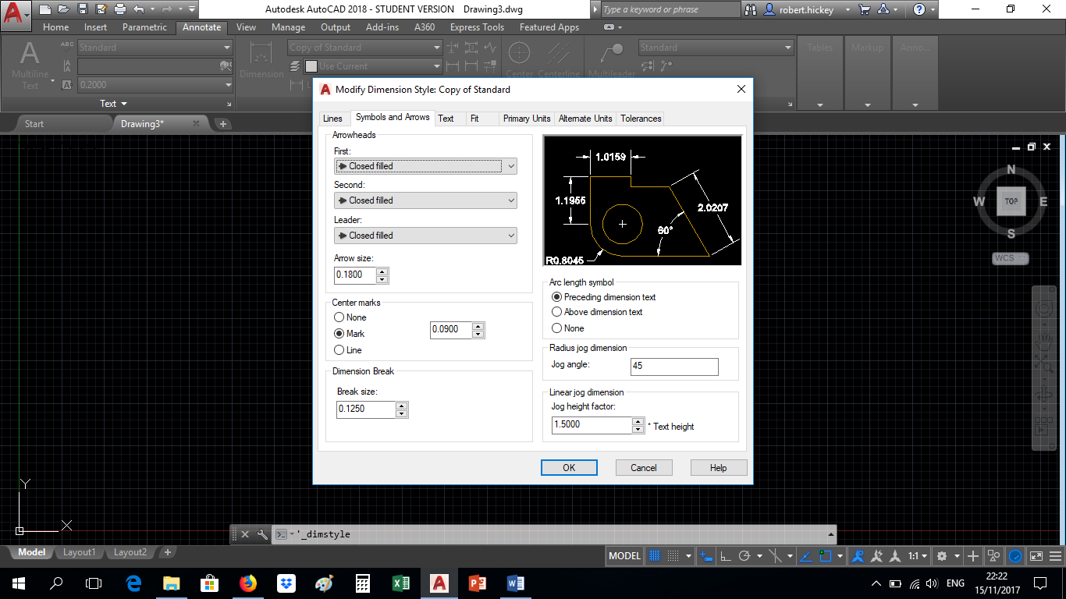The new style, which you have created, is identical to the STANDARD style, so you must now modify your new style so that it can be used to create dimensions, which conform to your own requirements.

Style changes are made in three categories, Geometry, Format and Annotation. As you can see from the Dimension Styles dialogue box, each category is represented by a Tab which leads to a dialogue box which is used to modify the settings in that particular category.

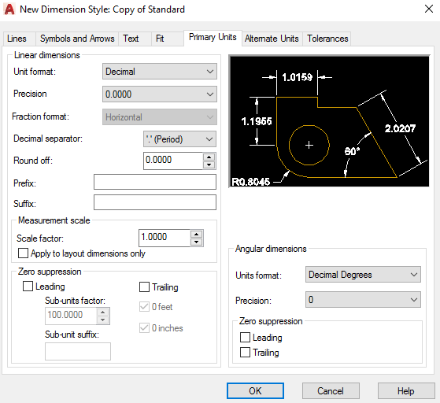2.3Dimension Scale

AutoCAD gives you the option to automatically include a unit prefix or suffix with the dimension to signify meters or millimetres, etc. Most usually, dimensions are drawn without units displayed but with a note on the drawing indicating, the units used, such as "All dimensions in meters". However, you may have a drawing where different units are being used for different elements of the drawing. In such a case it is a good idea to include units to avoid confusion.

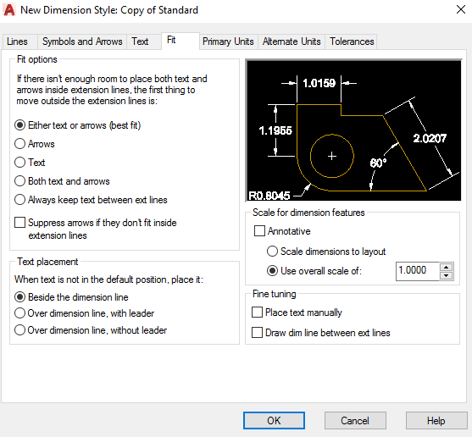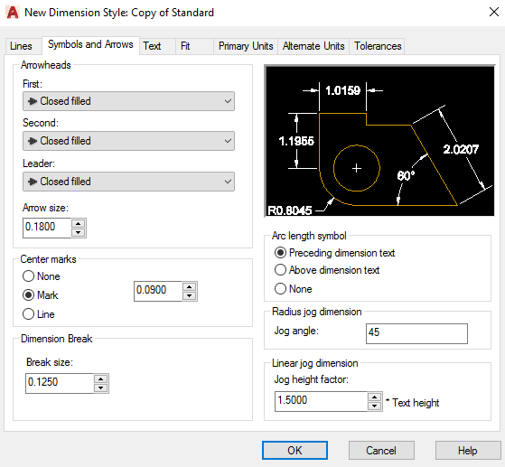Scale for dimension allows you to change the text height, arrow length, extension distances that you have prepared before by a predetermined factor. By default, it is set to 1 but if you change the overall scale value to 3, then all of the dimensioning arrows and texts will enlarge 3 times.

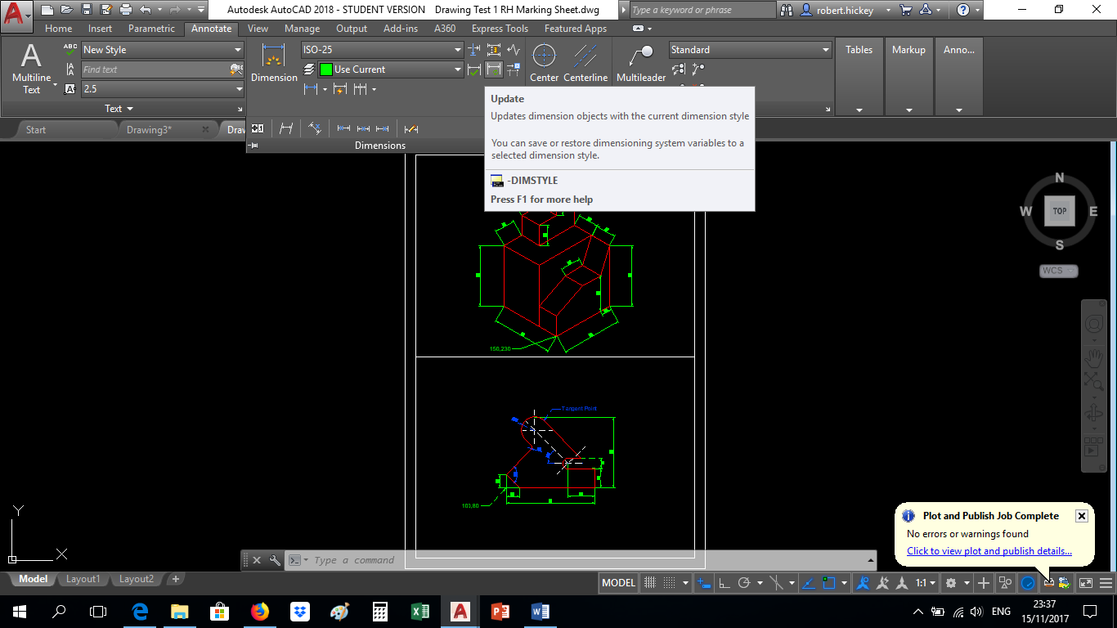2.4Dimension Update

This command is used to apply the current dimension style to existing dimensions.

Tips & Tricks

* Always attempt to use the least number of dimensions in order to provide the maximum amount of information.
* Avoid giving duplicate information. This will also avoid any ambiguity which may arise from inaccurate dimensioning.
* Sometimes it may be more appropriate to add notes to your drawing which include dimension information rather than attempt to dimension small or complex items.
* If you do not include any units information with your dimensions you must always add a note to your drawing such as "All dimensions are in millimetres" to make it absolutely clear.

## • Activity: 1

* Open a new drawing set the limits to A4 landscape 297,210.
* Create a layer for outlines and dimensions.
* Draw each of the objects shown and insert all the dimensions as illustrated.

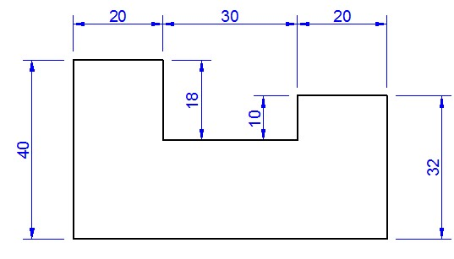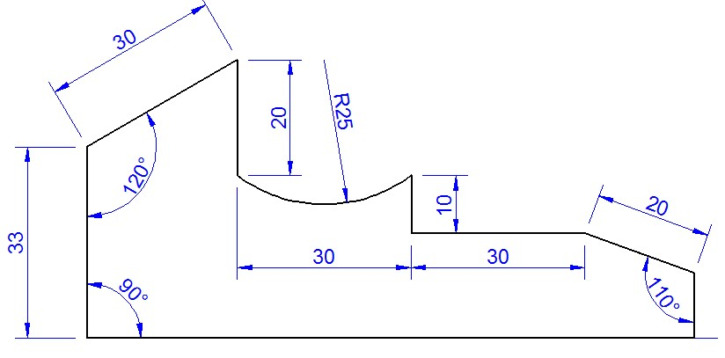

## • Activity: 2

* Create a layer for outlines, hatch styles and dimensions.
* Draw each of the objects shown and insert all the dimensions as illustrated.

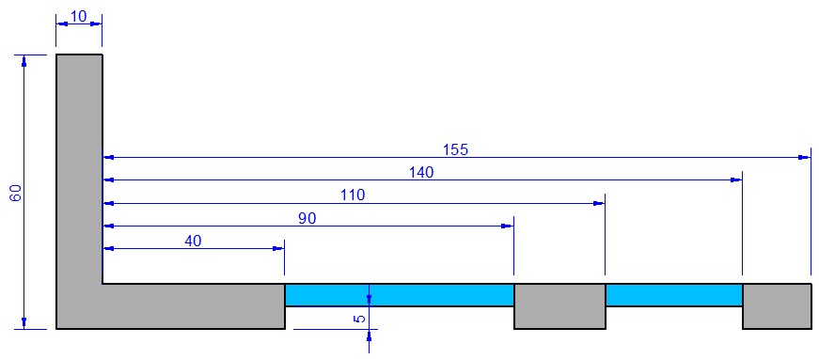

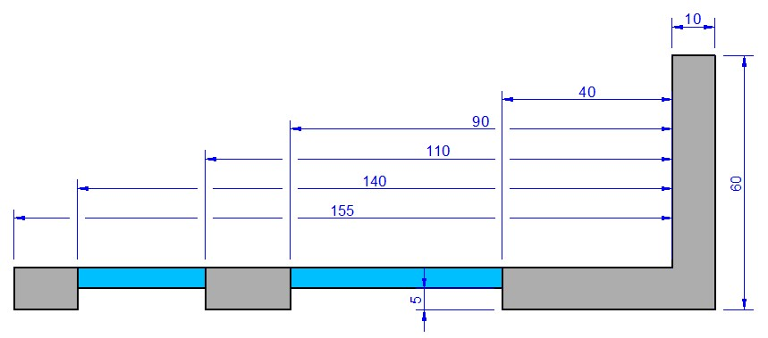

## Activity: 3

Create a new layer with the properties below and apply to all your existing dimensions.

Name: Comic 3mm

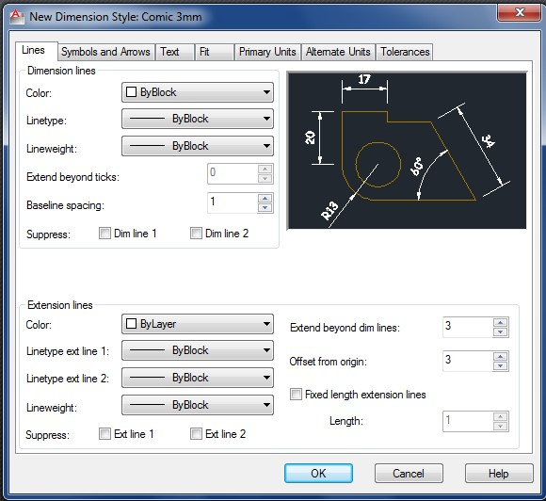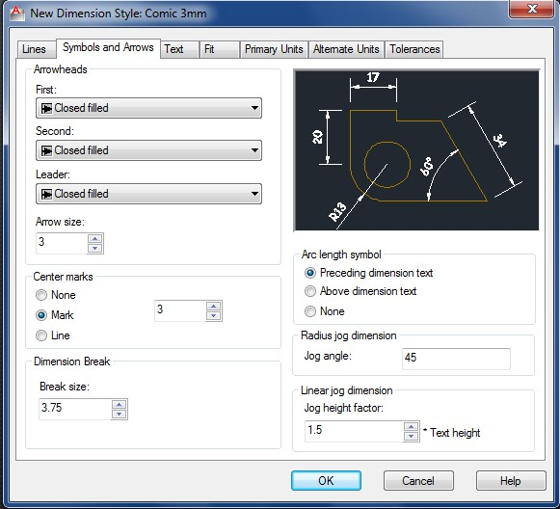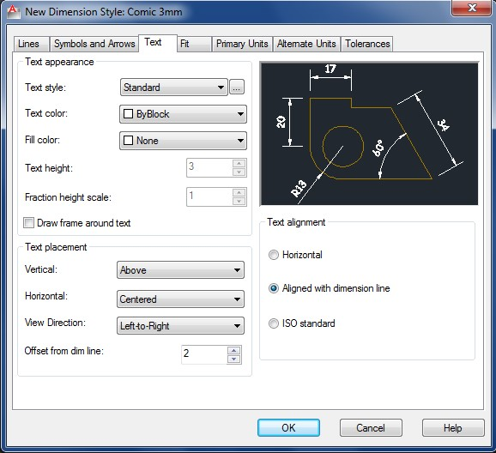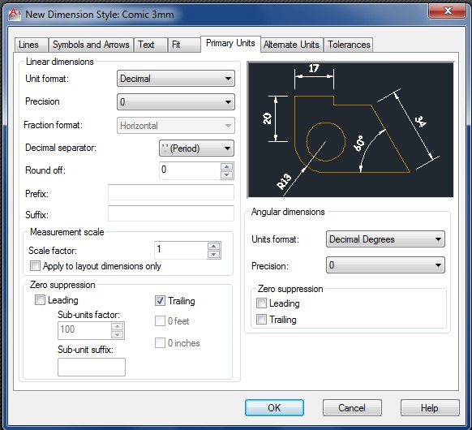

When completed email all CAD files to [Robert.hickey@tudublin.ie](mailto:Robert.hickey@tudublin.ie)