Introduction to AutoCAD

Lesson 7

Working with Blocks

Having attended Lesson 7 “Working with Blocks” you will be able to:

1.Describe what blocks are and why they are used

1. Create blocks.
2. Insert blocks.
3. Modify blocks.

1.What are Blocks.

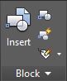A block in AutoCAD is a collection of all of the line and arc entities that create an object, 'moulded' together to make one selectable object. e.g. a motor, a metal plate, a bolt, a nut, a screw. They can be moved, rotated, mirrored etc. and will always be treated by AutoCAD as one whole object.

The only way to 'break' the block apart, and split it into its separate line entities, is to explode it.

Why use Blocks?

Blocks are an invaluable way of quickly arranging complex pieces of a drawing and they prevent accidental modification of parts of the object. Blocks also make it easy to duplicate the same object throughout a drawing, and as AutoCAD recognises that each copy of a block is identical to the previous, the memory & processing time required by AutoCAD is reduced. The most impressive feature of blocks is that if a block detail has to be amended, simply changing the detail and 'redefining' the block applies the changes to EVERY instance of the block in the drawing!

You can build up a library of blocks consisting of the parts that you use which can be stored in a separate folder or on networks so that all drafters have access to them.

# Screen Clipping2.How to Create Blocks

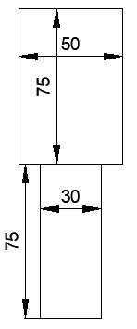Zero Layer has special properties. When creating blocks, if the objects in the block are drawn on Zero layer, they will assume the properties of the current layer when they are inserted. Drawing the block in any other layer will retain the properties of that layer in all instances. For this reason, blocks are drawn on the Zero layer as you need them to assume the layer's properties when being inserted.

* Open a new drawing and set the limits to A4 landscape 297,210.
* Draw the shape opposite in the centre of your workspace in “0” (Zero) layer.
* Do not include any dimensions on your drawing.

 Start the BLOCK command by either typing B or by clicking the Create button in the Block Group on the Home Tab. You will see a dialog box that looks like the one shown here. Enter information from the top and work your way down.

* Give your block a name.

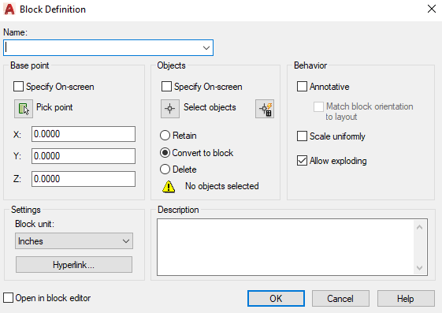

* Select an insertion/ base point.
* Select all the objects for your block and press 
* Insert description to add some quick specification or describe what the block is used for (more information = better).
* Click OK.

# 3.How to Insert Blocks

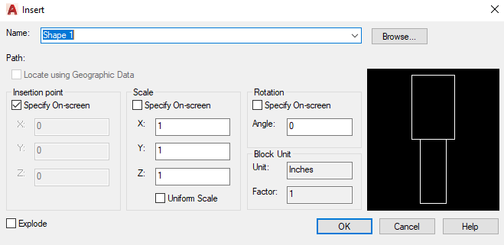Now that you have created a block, it's time to insert it. Change to the required new Drawing layer and then start the Insert command. By default, all the options you need are pre-selected. Since you only have one block in your drawing, its name is displayed, otherwise browse to the block location. Click OK. Pick anywhere on your screen and you will see the block appear. Notice how the block that you drew on the Zero Layer has now assumed the properties of the current layer.

# 4.How to Modify Blocks

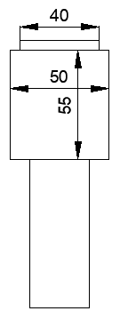As stated earlier, the most impressive feature of blocks is that if a block detail has to be amended, simply changing the detail and 'redefining' the block applies the changes to EVERY instance of the block in the drawing!

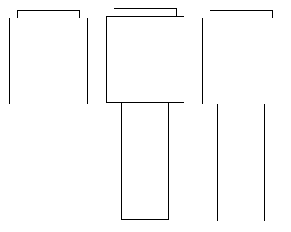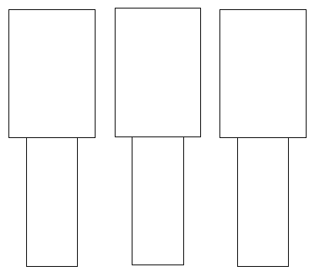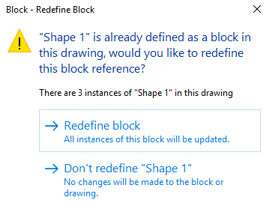To modify an existing block, simply create a new block using the existing block and give it the same name. When you select OK, you will be presented with the option to Redefine the block. By redefining the block, every instance of the block will be automatically updated on the drawing. See example below.

# Activity 1

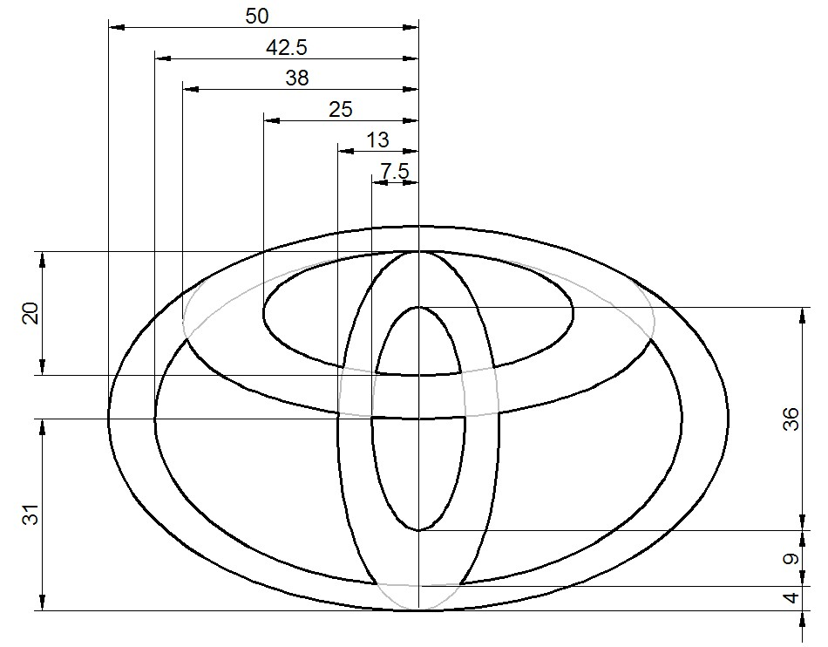

* Open a new drawing and set the limits to A4 Landscape 297,210.
* Draw the logo shown opposite in “0” (zero) layer.
* Create a block called Toyota
* Save as “Blocks”

# Screen ClippingActivity 2

* Draw the logo shown opposite in “0” (zero) layer.
* Create a block called Citroen
* Save as “Blocks”

# Screen Clipping Activity 3

* Open up the drawing called “First and Third Angle Projection Symbol”.
* Copy it and paste it into the “0” (zero) layer of your current Blocks file.
* Create 2 blocks from your copied drawings called First Angle Projection Symbol and Third Angle Projection Symbol.
* Save the file name as “Blocks”

# Screen ClippingActivity 4

* Open a new drawing and set the limits to A4 Landscape 297,210.
* Click the Insert button in the Block Group on the Home Tab.
* 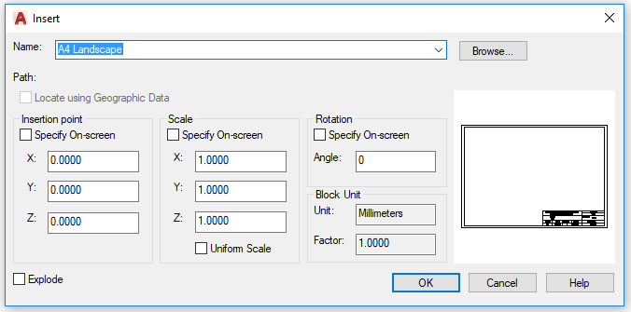Browse to the “A4 Template” file used in “Lab 1”and select it.
* Make sure that none of the boxes are ticked and then click OK.
* Save the new file name as “A4 Title Block”.

When completed email all CAD files to [Robert.hickey@tudublin.ie](mailto:Robert.hickey@tudublin.ie)