Introduction to AutoCAD

Lesson 8

1st & 3rd Angle Projection

Having completed Session 8 1st & 3rd Angle Projection, you will be able to:

1. Combine prior learning - set out and complete the attached drawing (A4 handout to A2 AutoCad sheet limits).

## Set up drawing as follows:-

Open a new Cad drawing:-

* Save the drawing as First and Third Angle Projection - Your Name.
* Set limits for A2 portrait - A2 420 mm x 594 mm.
* Draw an outline at the limits using the appropriate layer (Outline Border) as below.
* Set out other layers as detailed in section 2.

1. 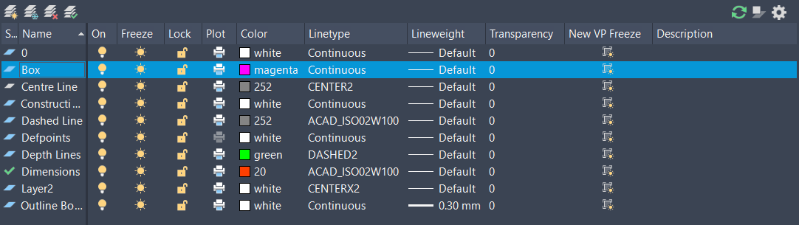Set up new Layer Styles.
2. Complete all views as shown on the handout.

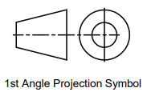The attached handout showing an engineered part, details the following:-

* Front, R Side, L Side, Rear, Top and Bottom views.
* 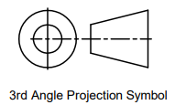First Angle Projection of the Top, Front and R Side views (including appropriate symbol).
* Third Angle Projection of the Top, Front and R Side views (including appropriate symbol).
* Isometric view of the part (this view, can only be completed after all other views are drawn).

Complete all views as shown on the handout paying attention to the following:-

* Only include dimensions on part views as shown inside the ‘Box’ - layer - magenta colour.
* Locate all views as per dimensions shown
* Set suitable scaling for broken/dashed lines
* Set Snap and Grid as per screenshot section 4 below:-

1. Snap and Grid Settings.

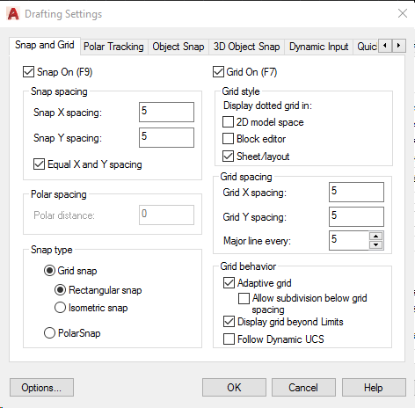

1. Text Styles.

Set text styles as follows:-

Autodesk AutoCAD 2018- EDUCATIONAL VERSION 
View Manage Output Add- ins A360 Express TK 
Home 
AaBb123 
Annotative 
Mask 
Insert Annotate 
Parametric 
AaBb123 
Standard 
Style 
5 
Match 
8yLayer 
Formatting 

1. 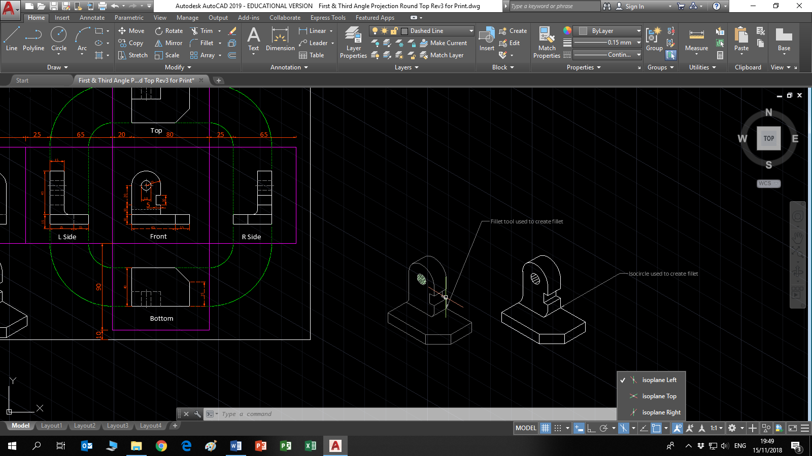Isometric Details.

In order to complete the Isometric detail the following commands will be required to draw the ‘Isocircle/s’:-

* ISODRAFT – command or click on the isometric draft button on the bottom toolbar.



* Select – Isoplane Left
* Ellipse – command Axis, End



* Select – Isocircle

Sbe c ify —Ski'S' e 
ELLIPSE Specify center of isocircle: 

* Enter radius/diameter

**Note**: If you were drawing, the isocircle on the top plane you would choose the isoplane top.

When drawing is completed email CAD file to [Robert.hickey@tudublin.ie](mailto:Robert.hickey@tudublin.ie)