Introduction to AutoCAD

Lesson 9

Paper space - Layout

Having attended the “Paper space - Layout” class, Lesson 9 you will be able to….

1. Create new & modify existing layouts for specific printers & plotters.
2. Insert title block onto layout.
3. Insert, scale and modify viewports.
4. Manage layers within viewports.
5. Plot & Publish completed drawings.

Introduction

Paper Space

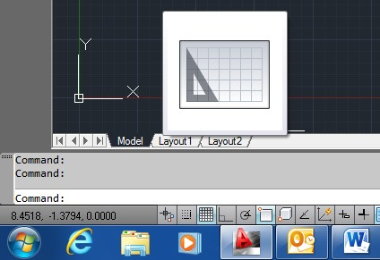

There are two drawing areas within the AutoCAD window, “Model” space and Paper space. (Layouts) When AutoCAD is first loaded, the drawing area which is seen is known as Model space (the black screen) and all drawing or 'Modelling' done within AutoCAD is drawn in Model space. Tabs next to the Model space tab named 'Layout1' and 'Layout2' are shortcuts to the two default Paper space views. Layouts are used for creating separate pages onto which you can paste different views of your drawing by adding/inserting what are called “floating viewports” in order to print different views or parts of your drawing.

1. Insert title block onto layout.

Title blocks can be inserted onto the Layout sheet using a number of different methods.

* Paper space can be treated just like Model space and a border and title block can be drawn directly onto the Layout sheet or a “Block” can be inserted.
* An existing drawing can be copied & pasted or dragged & dropped onto the Layout.

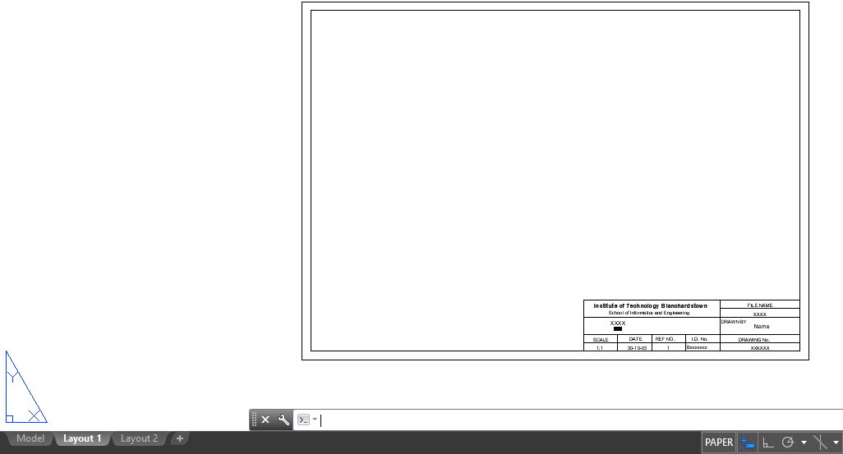Note: Before inserting a title block, create a new layer specifically for the title block and use this layer to control viewing options.

* Download the CAD file titled “Test 1 Activity 2” from the module resource webpage <https://www.learning101.ie/autocad.html#bottom> and open it.

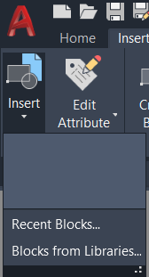

* Select the tab beside “Model” space “Layout 1” Paper space view and then click the insert “Block” button dropdown arrow.
* 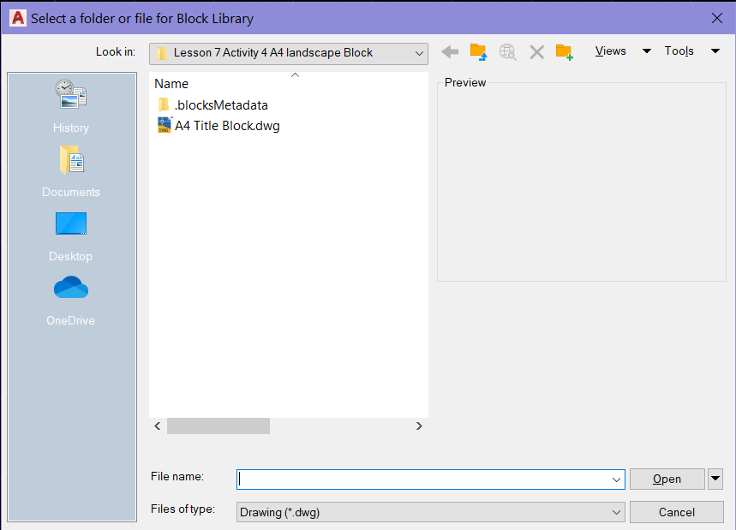From the dropdown select Blocks from “Libraries”, and from the pallet on the right of the screen left click and launch the “File Navegation Dialouge Box” button to browse to the location of your saved file “A4 Title Block” Block. (**you can download this “A4 Title Block” file from the module website page**) Browse to the folder containing the “A4 Title Block” file and left click Open.

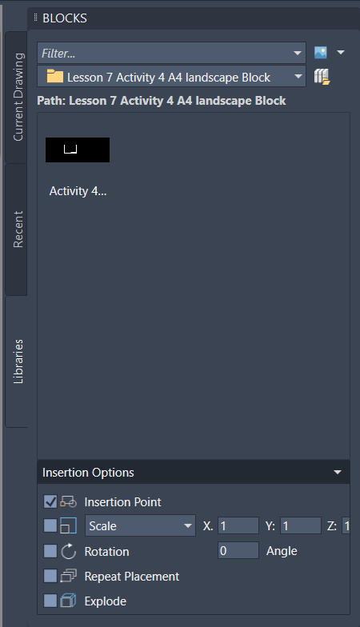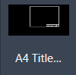

* When it appears in the pallet window, double left-click on the file icon and then choose your insertion point on the layout page. Make sure it fills the full A4 page.
* We will use the drawing from your first test for creating and working with multiple viewing ports in paper space.

1. Insert, scale and modify viewports.

Having set up the paper space Layout 1 page, it is now time to insert some viewports. Create a new layer for inserting viewports and make it current. This will allow you to freeze the viewport border prior to printing.

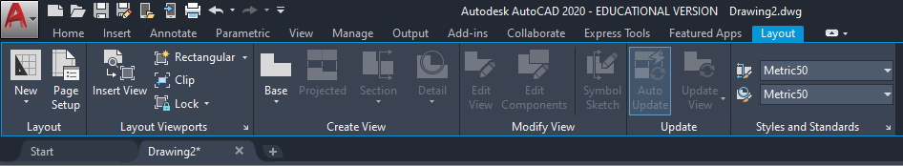The simplest method is to insert a single viewport and size it to fit the page. On the “Layout” Tab in the “Layout Viewport” Group, click on the “Rectangular” viewport button or type MV in the command line.

Then simply left click once to pick the top left corner of your viewport window, then pick and click the opposite bottom right corner to form your rectangle and define your view area.

These viewports can be moved, scaled, copied and stretched just like any AutoCAD entity. You can create more viewports as required, including polygons and other shapes.

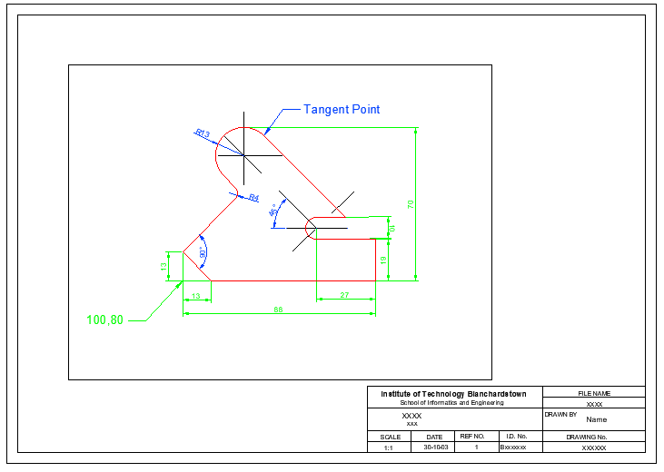To edit what you see in the viewport as if it were the normal drawing area just double left click inside the border. To work outside of the viewport, just double left click outside of the border. Only one viewport can be active at any one time and the current active viewport is highlighted with a thick border. Any changes you make to the drawing in one viewport will be simultaneously made in the other viewports as well as the Model space.

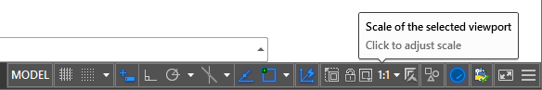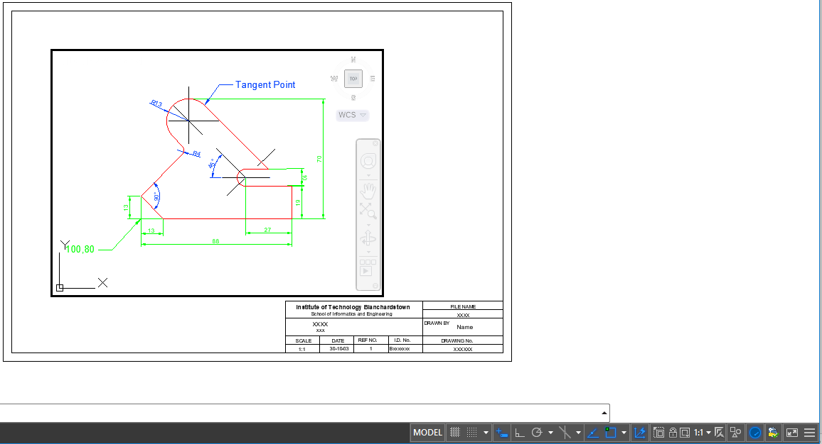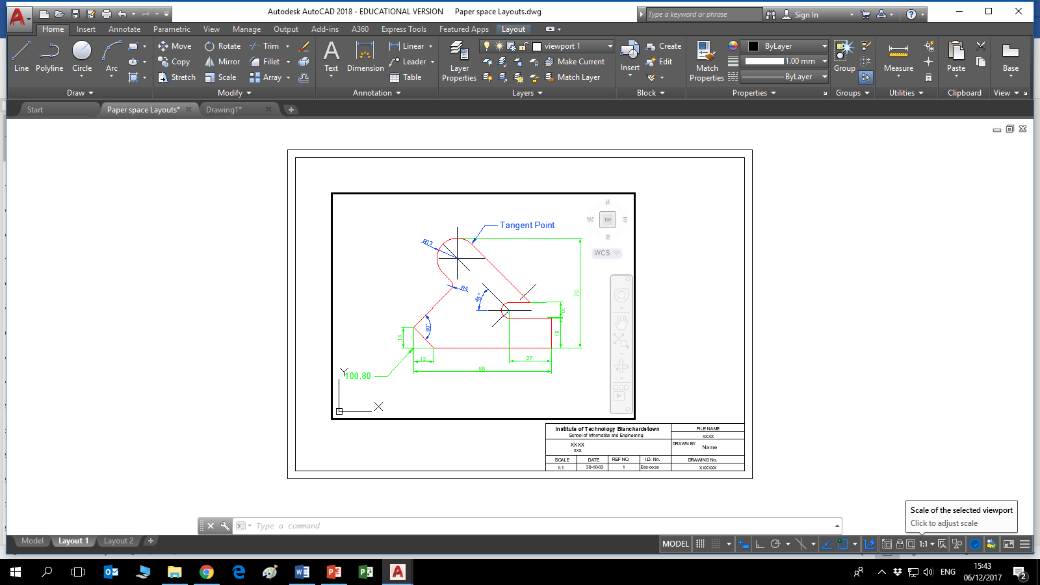The scale of the drawing within the viewport can be set using the viewport scale options from the status bar, and the drawing can then be panned to the desired position within the viewport. Once happy with the view, position and scale of the viewport, it is a good idea to “**Lock**” that particular viewport to prevent accidental modifications. (see below for scale & lock tools)

1. Manage layers within viewports.

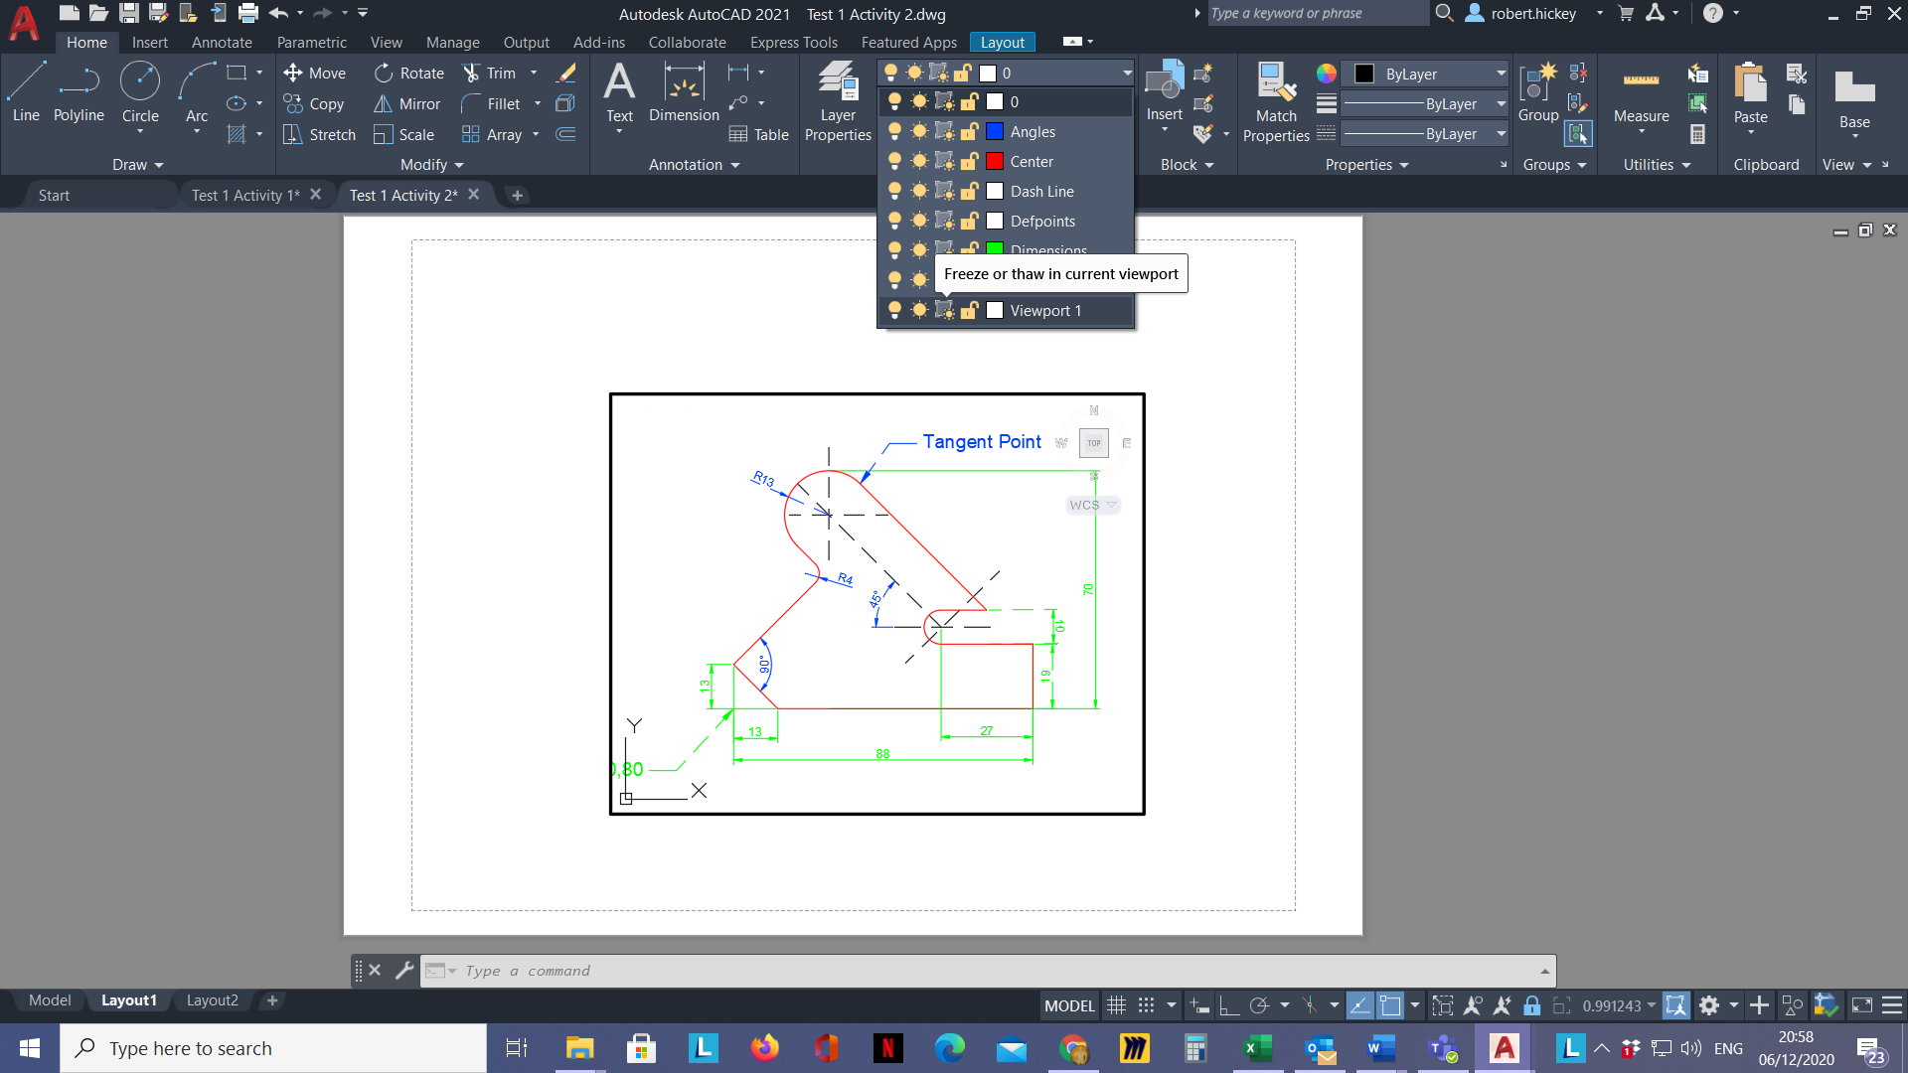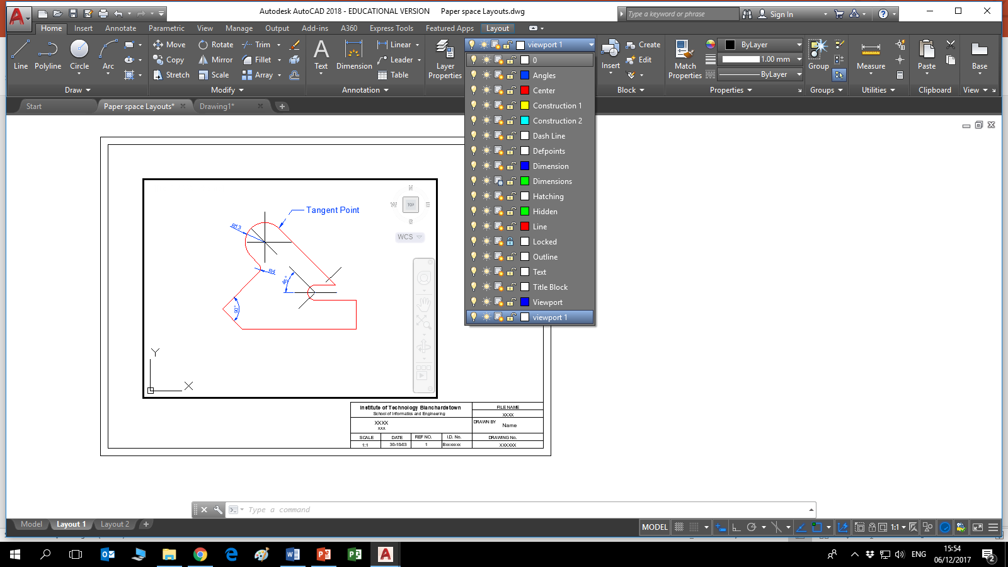It is possible to display, freeze and print different layers in each of the different viewports. This is achieved by firstly making the viewport active (double left click inside the viewport window border) and opening the layer properties manager. From here, plot options as well as Freeze or thaw in current viewport, linetype and colour can be modified. Note: the viewport freeze selection appears as a

new column in the layers dropdown when you are in the “Layout” paper space.

1. Plot & Publish completed drawings.

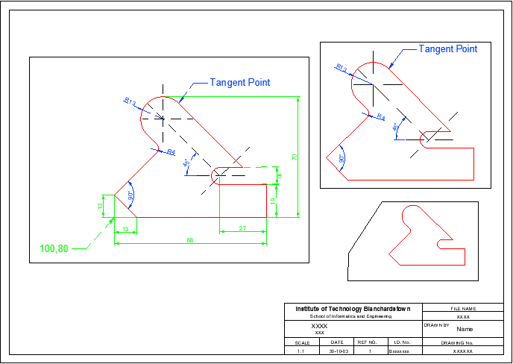There are some things to bear in mind when plotting from Paper Space. First of all, since the drawing sheet has been drawn at full size and in millimetres the plot scale is always 1=1. It is possible to freeze layers in the current viewport but have them remain visible in all other viewports.

There are three viewports in the example, all showing different views and scales of the same drawing. The plotting of the viewport borders can be suppressed by turning off the layer on which they were created. They have been left visible in this example.

Finishing Touches - At this stage, the current sheet should consist of a title block and border, along with one or more correctly arranged viewports. All that's left is to plot the drawing.

1. Create new & modify existing layouts for specific printers & plotters

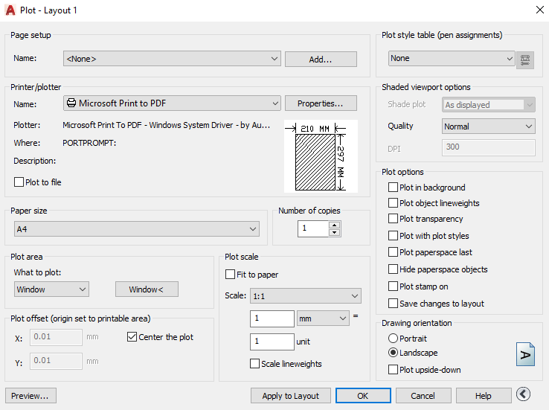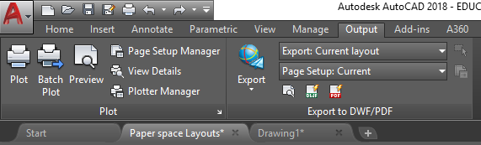 On the “Output” Tab in the “Plot” Group click “Plot”. From here, you can modify an existing layout or Add a new one. After you choose or add a name for the page set-up for the layout, select the desired printer, paper size, scale and orientation as well as additional plotting options. In the example below we are plotting to a PDF so there is no need to add a setup name. Note that the plot area has been selected using the window option.

# Activity 1

* Open up a copy of the drawing from the module resource webpage titled “**Test 1 Activity 1**”, save it to your desktop, and rename it Paper space Layout 1.
* 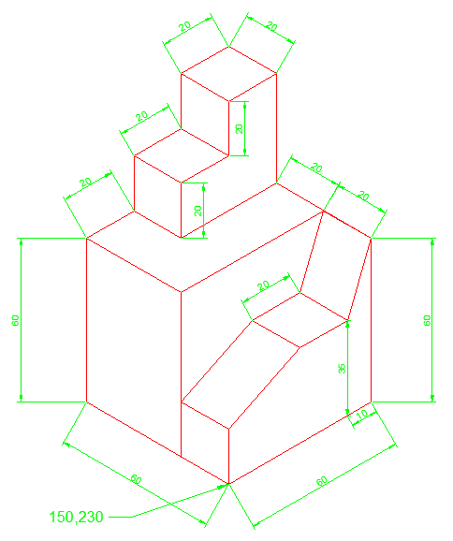Select Layout 1 Tab and then insert the “**A4 Portrait Title Block**” also downloaded from the module resource webpage.
* Create 2 different viewports in this Paper space for plotting, one showing dimensions and one without to an appropriate scale. Then proceed to plot the Paper space to a PDF and call it Test 1 PDF.
* Save the files and email them to me at [Robert.hickey@tudublin.ie](mailto:Robert.hickey@tudublin.ie)