Lab 1

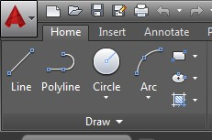

Introduction to AutoCAD

AutoCAD Orthographic and Grid functions

Exercise 1a – ORTHO, SNAP and GRID

1. Start a new file using the A4 template provided on the AutoCAD webpage “[Workbook Section](https://www.learning101.ie/autocad.html)”.
2. Draw the objects below using:
   1. Line command
   2. Ortho (F8) on when drawing horizontal and vertical lines
   3. Ortho (F8) off when drawing lines at an angle
   4. Turn Increment snap (F9) on (snaps to grid)
   5. Turn Osnap (F3) off (will not snap to line end points)
   6. Turn Grid (F7) on
   7. Use the shift key to toggle Ortho ON and OFF as you draw your shapes

**Note – for this exercise, dimensions are not important – just guess!**

1. Save the drawings as Lab 1 Exercise 1a

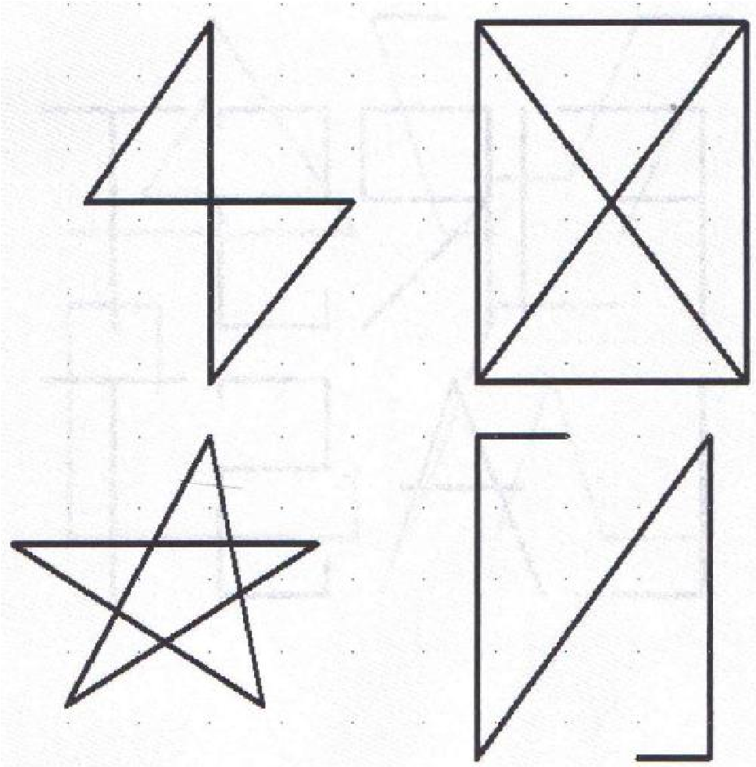

Exercise 1b – Basic Shapes

1. Start a new file using the A4 template provided on the AutoCAD webpage “[Workbook Section](https://www.learning101.ie/autocad.html)”.
2. In the “snap settings” to make drawing much easier change the increment snap to 0.20 and grid spacing to 0.40

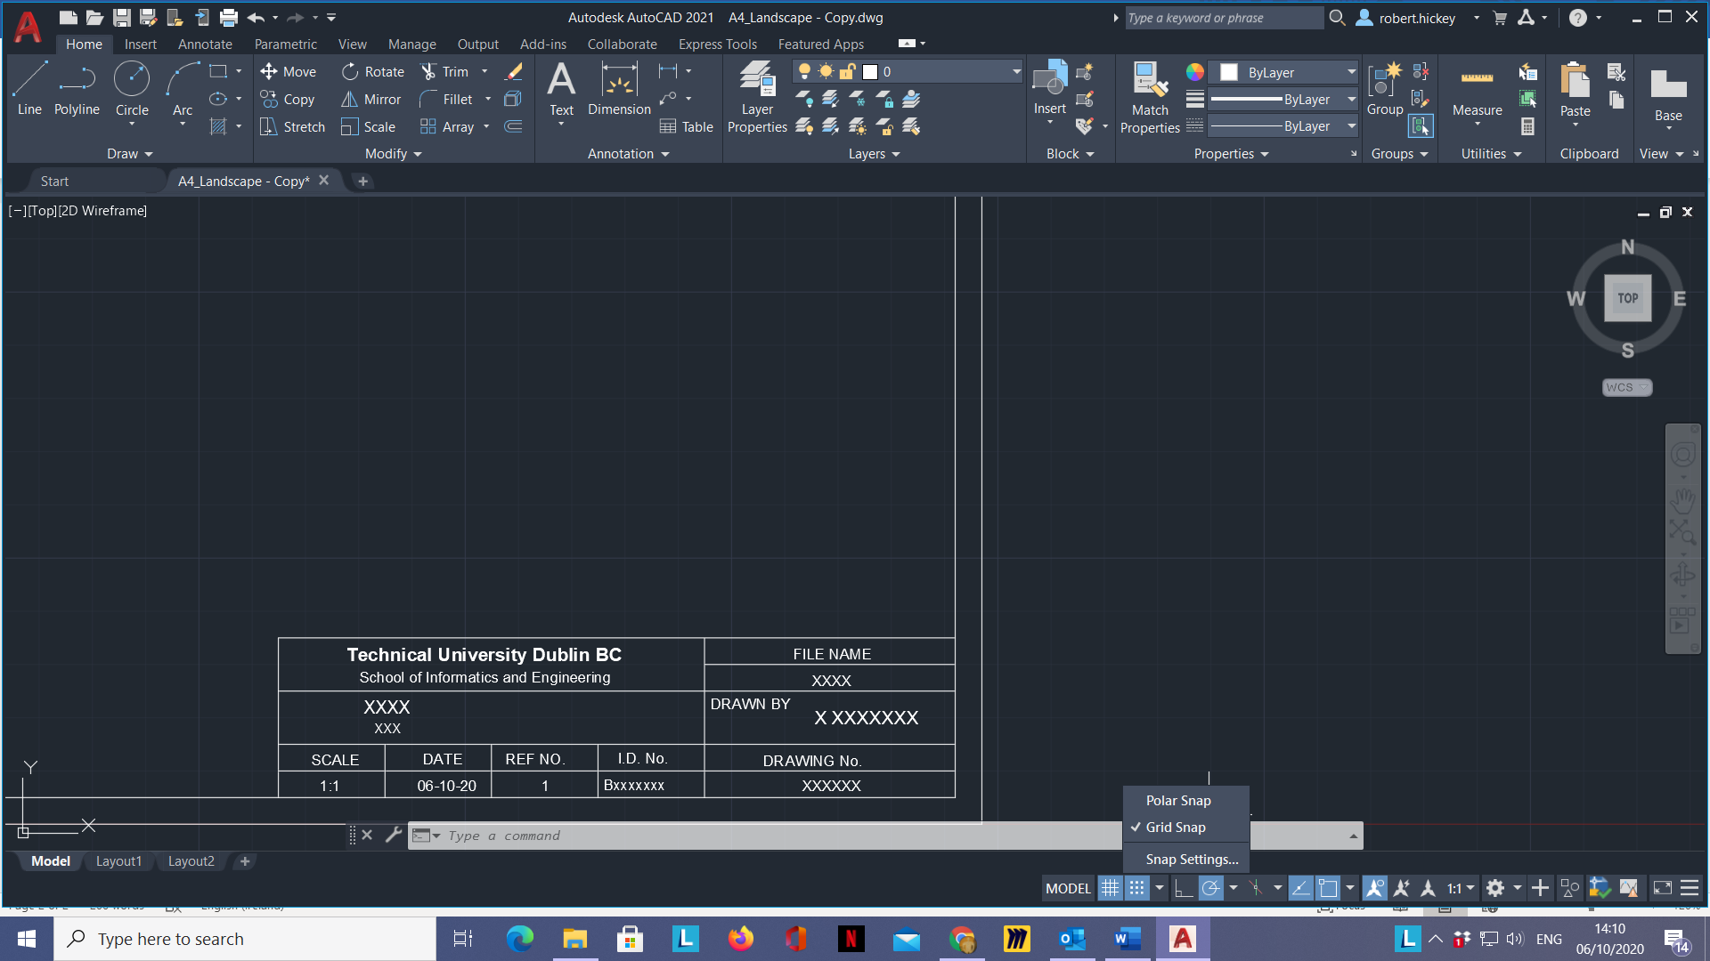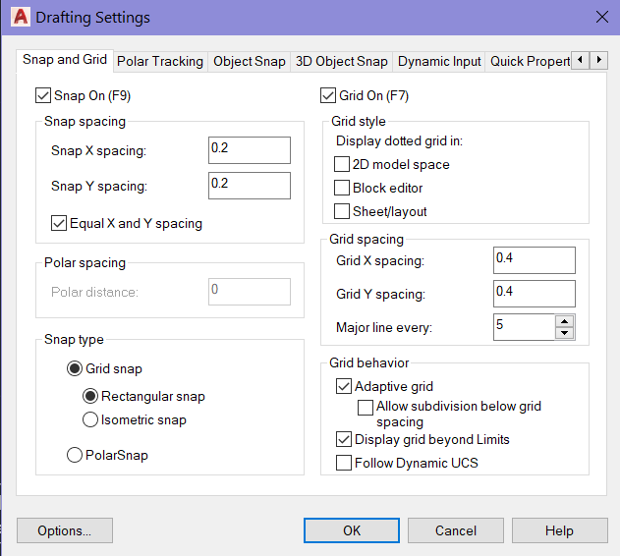

1. Ensure Snap and Grid status bar buttons are on i.e. highlighted in blue.
2. Draw the objects below using layer “Object Line”

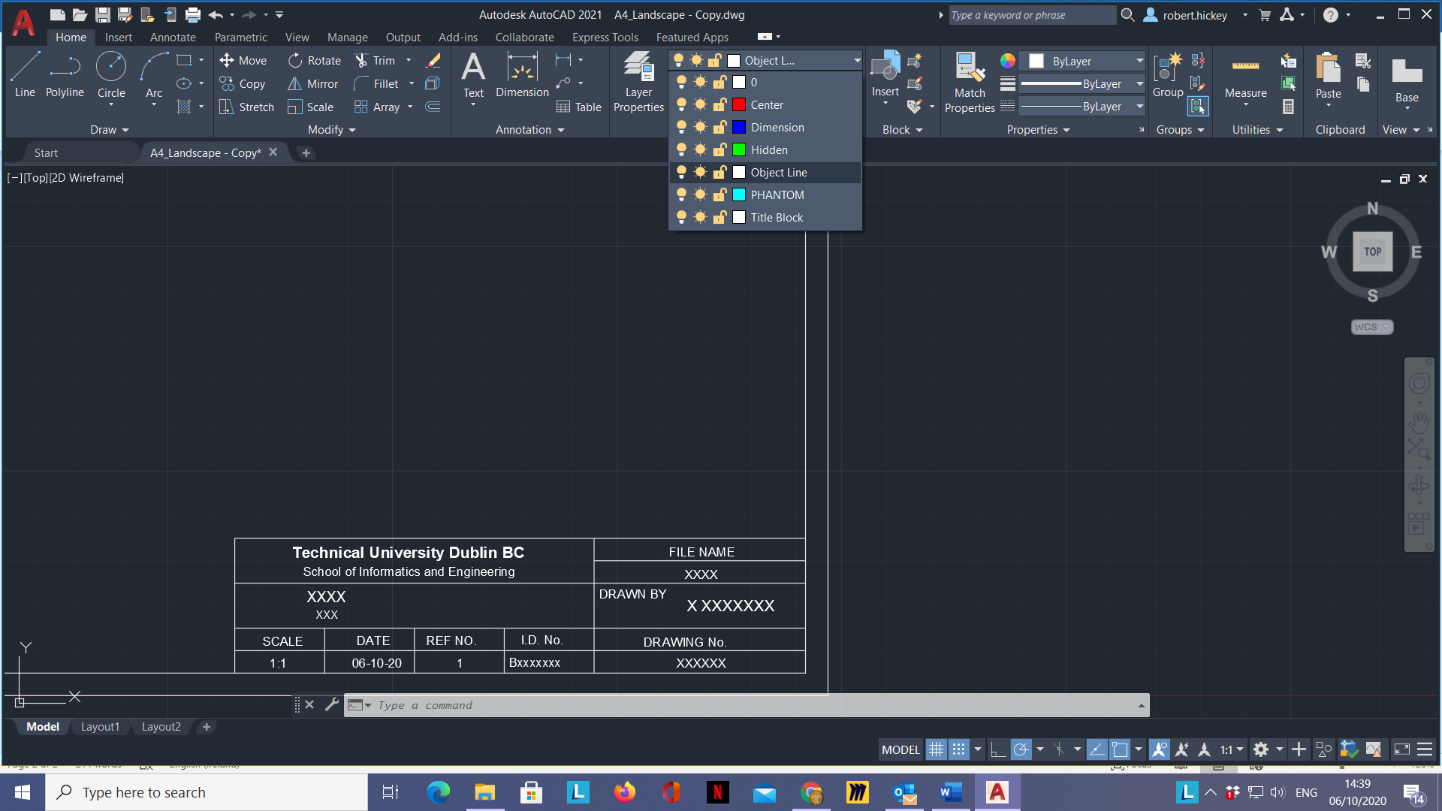

1. Do not dimension
2. Save the drawing as Lab 1 Exercise 1b

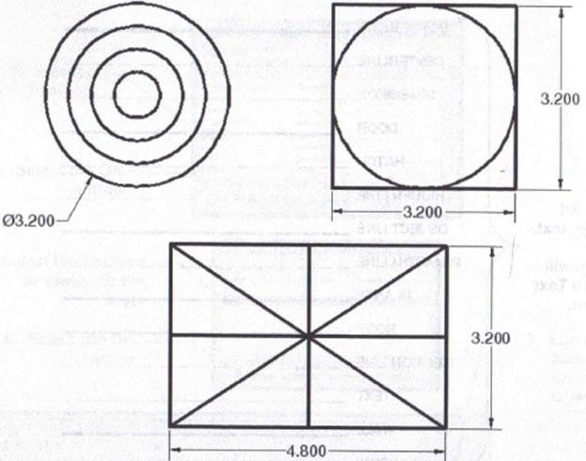

When you are finished both exercises, email me the two AutoCAD files [robert.hickey@tudublin.ie](mailto:robert.hickey@tudublin.ie) for feedback.