

**Student Name: Robert Hickey**

**Student Number: B0000123456**

**Date due: 7th October 2024**

**Assignment Title: First Report**

**Word Count: 328**

**Module Title: Introduction to Instrumentation**

**Course: BSc Process Instrumentation & Automation**

Table of Contents

1 Assignment Brief 1

2 Report structure 1

2.1 Formatting 1

2.1.1 Submission Guidelines 2

3 References 3

Figure:1 Tip: use the Multilevel List tool for assigning your numbering system to your heading styles 1

Figure:2 Example of Heading Styles using a hierarchical numbering system 2

Equation:1 Binomial Theorem 2

Equation:2 Fourier Series 2

# Assignment Brief

Choose any topic from the field of Process Instrumentation and Automation that interests you. Use this [template](https://www.learning101.ie/files/reporttemplate2023.docx) for writing your research assignment.

Tip: you can use the following resources as a starting point (Measurement & Control Journal, 2024), (Institute of Measurement & Control, 2024), (Google Scholar, 2024)

You should research this topic and write a report explaining its origins i.e., **where it was first used**, **how it is used** in society and or industry today and **how it might be used** in the future.

Word count 800 ± 10%

# Report structure

1. Cover Page
2. Table of Contents
3. Table of Figures
4. Table of Equations
5. Introduction
6. Summary
7. Main section headings and subheadings
8. Conclusion
9. References (start at the top of a new page)

## Formatting

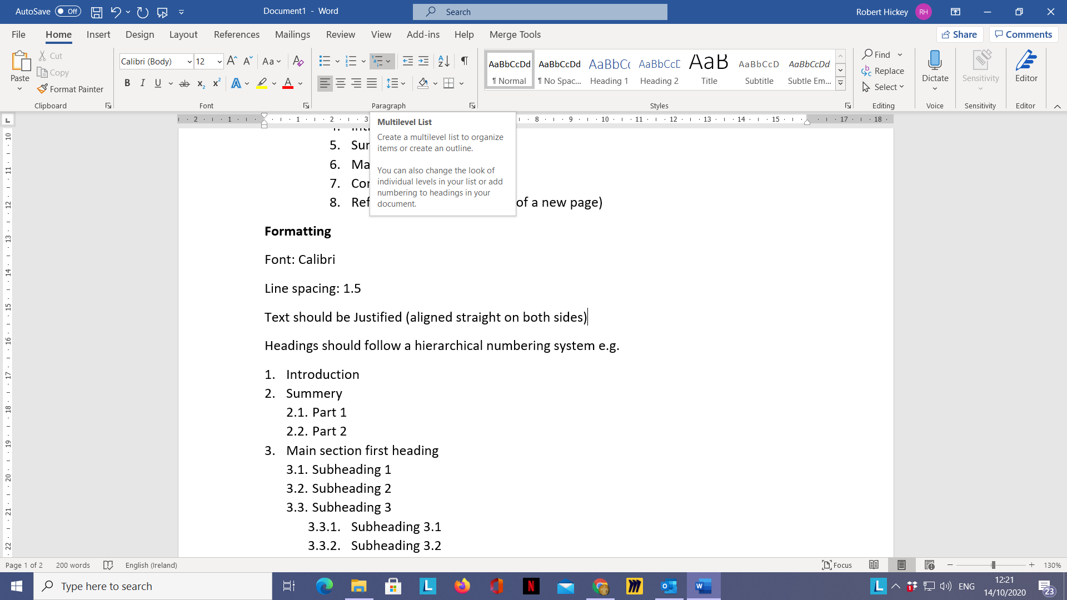

Font: Calibri, Size 12pt

Line spacing: 1.5

Text should be Justified (aligned straight on both sides)

Headings should follow a hierarchical numbering system (see Fig 1 & 2)

Figure:1 Tip: use the Multilevel List tool for assigning your numbering system to your heading styles

Heading 1 style: Calibri, Size 14pt, Bold, left aligned

Heading 2 style: Calibri, Size 12pt, Bold, left aligned, indented by 3cm

Heading 3 style: Calibri, Size 12pt, Bold, left aligned, *italicized,* indented by 5cm

### Submission Guidelines

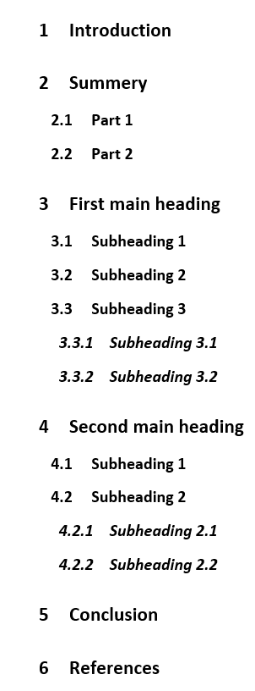You should email a copy of your report to [Robert.hickey@tudublin.ie](mailto:Robert.hickey@tudublin.ie) before the due date. I will then give detailed feedback using the review tools built into word. Here is a video showing you how to use the review tools once I have sent you your feedback <https://www.youtube.com/watch?v=2cy09Xty6_8&feature=youtu.be>

Equation:1 Binomial Theorem

$${\left(x+a\right)}^{n}=\sum_{k=0}^{n}{\left({n \atop k}\right)x^{k}a^{n-k}}$$

Equation:2 Fourier Series

$$f\left(x\right)=a_{0}+\sum_{n=1}^{∞}{\left(a_{n}\cos{\frac{nπx}{L}}+b_{n}\sin{\frac{nπx}{L}}\right)}$$

Figure:2 Example of Heading Styles using a hierarchical numbering system

**Note:** You should try and include some equations in your report for practice, as you will be required to insert and work with equations using the editor in word (see two examples above Equation:1 & Equation:2). Click for [video demo](https://www.youtube.com/watch?v=AarTPACrSoM&feature=youtu.be) how to insert and position equations in word.

# References

Google Scholar, 2024. *Google Scholar.* [Online]   
Available at: https://scholar.google.com/  
[Accessed 14 09 2024].

Institute of Measurement & Control, 2024. *InstMC Publications.* [Online]   
Available at: https://www.instmc.org/Publications  
[Accessed 14 09 2024].

Measurement & Control Journal, 2024. *Engineering Sage Journals.* [Online]   
Available at: https://journals.sagepub.com/home/mac  
[Accessed 14 09 2024].