

**Student Name: Robert Hickey**

**Student Number: B0000123456**

**Date due: 2nd & 4th of December 2024**

**Assignment Title: Final Report**

**Word Count: 464**

**Module Title: Introduction to Instrumentation**

**Course: BSc Process Instrumentation & Automation**

Table of Contents

1 Assignment Brief 1

2 Report structure 1

2.1 Formatting (Tip: use the template provided) 1

2.1.1 Submission Guidelines 2

3 References 3

**Table of Figures**

Figure:1 Tip: use the Multilevel List tool for assigning your numbering system to your heading styles 2

Figure:2 Example of Heading Styles using a hierarchical numbering system 2

**Table of Equations**

Equation:1 Binomial Theorem 2

Equation:2 Fourier Series 2

**Table of Tables**

Table 1 Formatting Guidelines for Report 1

# Assignment Brief

Once you have received feedback for your second report and completed all the recommended changes you should start working on the following.

Having chosen your report topic and carried out some tentative research you now have a chance to modify, refine and improve your final research report.

**Tip**: you can use the following resources to continue your reading and research (Measurement & Control Journal, 2024), (Institute of Measurement & Control, 2024), (Google Scholar, 2024). There are literally endless resources available on Google Scholar, not to mention the college library data base’s, use them, read a lot and include at least 15 credible separate sources for your references to support your arguments in this final report.

You should continue your reading and research around your chosen topic and write a report **explaining its origins** i.e., **where it was first used**, **how it is used** in society and or industry today and **how it might be used** in the future.

Word count 2,000 ± 10%

# Report structure

1. Cover Page (as per template provided)
2. Table of Contents (make sure to update all automatic tables before submitting)
3. Table of Figures (must include images & tables in your report) How to [video demo](https://www.youtube.com/watch?v=dxOpEB-RnZY&feature=youtu.be)
4. Table of Equations (must include at least one equation in your report)
5. Table of Tables
6. Introduction (max 150 words)
7. Summary (main findings from your research)
8. Main section headings and subheadings (as many as you like, make them descriptive)
9. Conclusion
10. References (start at the top of a new page) (at least 15 separate sources, not .com)

## Formatting (Tip: use the template provided)

Table Formatting Guidelines for Report

|  |  |
| --- | --- |
| Font: | Calibri, Size 12pt |
| Line spacing: | 1.5 |
| Text should be Justified | (Aligned straight on both sides) |
| Headings: | Should follow a hierarchical numbering system (Figure 1 & 2) |
| Heading 1 style: | Calibri, Size 14pt, Bold, left aligned |
| Heading 2 style: | Calibri, Size 12pt, Bold, left aligned, indented by 3cm |
| Heading 3 style: | Calibri, Size 12pt, Bold, left aligned, *italicized,* indented by 5cm |

### Submission Guidelines

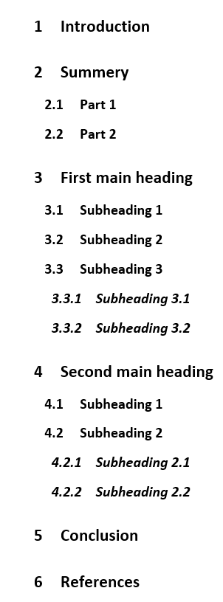You should email a copy of your report to [Robert.hickey@tudublin.ie](mailto:Robert.hickey@tudublin.ie) before the due date 2nd & 4th of December at the end of class. You will receive some final feedback on your level of work and performance in relation to your researching and report writing skills you developed over the duration of the semester.

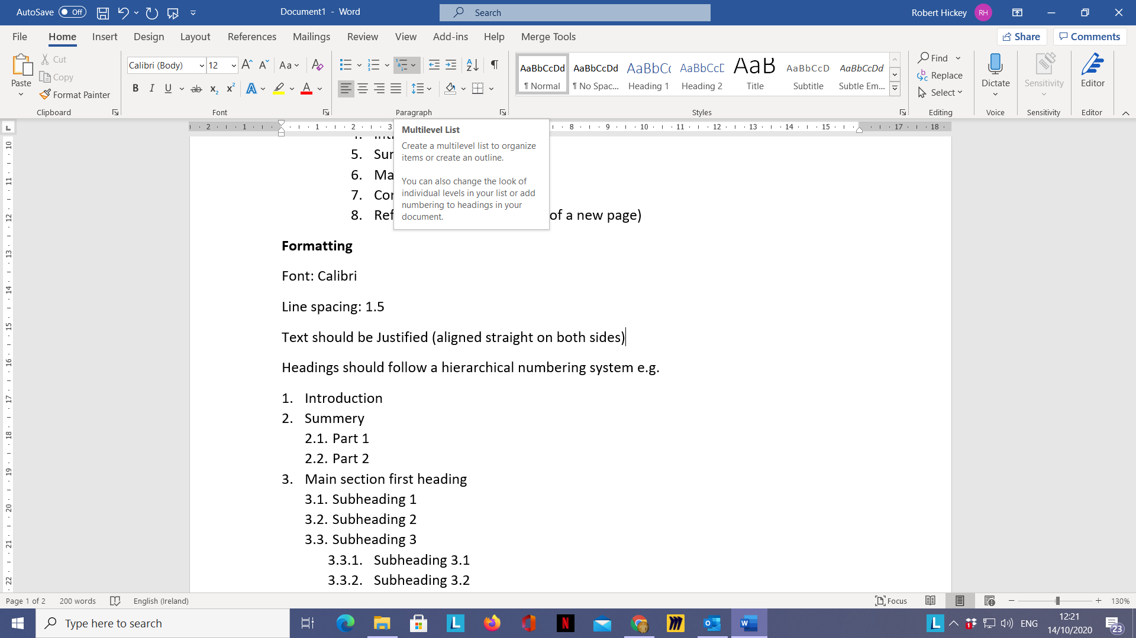

Figure: Tip: use the Multilevel List tool for assigning your numbering system to your heading styles

Equation: Binomial Theorem

Equation: Fourier Series

Figure: Example of Heading Styles using a hierarchical numbering system

**Note:** You must include some equations in your report for practice, using the equation editor in word (Equation 1 & 2). Click for [video demo](https://www.youtube.com/watch?v=AarTPACrSoM&feature=youtu.be). You must also include at least 1 table in your report (Table 1).

# References

Google Scholar, 2024. *Google Scholar.* [Online]   
Available at: https://scholar.google.com/  
[Accessed 04 11 2024].

Institute of Measurement & Control, 2024. *InstMC Publications.* [Online]   
Available at: https://www.instmc.org/Publications  
[Accessed 04 11 2024].

Measurement & Control Journal, 2024. *Engineering Sage Journals.* [Online]   
Available at: https://journals.sagepub.com/home/mac  
[Accessed 04 11 2024].